## **SOIL ANALYZER**

## A PROJECT REPORT

*Submitted by*

# PRAKASH Y [Reg No:RA2011003010044]

# S JAGADEESH [Reg No: RA2011003010125]

*Under the Guidance of*

# Dr. P. RAMA

Assistant Professor, Department of Computing Technologies

*in partial fulfillment of the requirements for the degree of*

**BACHELOR OF TECHNOLOGY**

# in

**COMPUTER SCIENCE AND ENGINEERING**



**DEPARTMENT OF COMPUTING TECHNOLOGIES**

# COLLEGE OF ENGINEERING AND TECHNOLOGY

# SRM INSTITUTE OF SCIENCE AND TECHNOLOGY KATTANKULATHUR– 603 203

**OCTOBER 2023**



# SRM INSTITUTE OF SCIENCE AND TECHNOLOGY

# KATTANKULATHUR–603 203

## **BONAFIDE CERTIFICATE**

Certified that the 18CSP107L project report titled “**SOIL ANALYZER**” is the bonafide work of **PRAKASH Y [RA2011003010044]** and **S JAGADEESH [RA2011003010125]** who carried out the project work under my supervision. Certified further, that to the best of my knowledge, the work reported here does not form part of any other thesis or dissertation based on which a degree or award was conferred on an earlier occasion for this or any other candidate.

### Dr. P. RAMA

### SUPERVISOR

Assistant Professor

Department of Computing Technologies

### Dr. P. Selvaraj

### PANEL HEAD

### Associate Professor

### Department of Computing Technologies

### Dr. M. PUSHPALATHA

### HEAD OF THE DEPARTMENT

Department of Computing Technologies



Department of Computing Technologies

# SRM Institute of Science and Technology Own Work Declaration Form

**Degree/Course:** B.Tech in Computer Science and Engineering

**Student Names:** PRAKASH Y, S JAGADEESH

**Registration Number:** RA2011003010044, RA2011003010125

**Title of Work: SOIL ANALYZER**

I/We hereby certify that this assessment compiles with the University’s Rules and Regulations relating to Academic misconduct and plagiarism, as listed in the University Website, Regulations, and the Education Committee guidelines.

I / We confirm that all the work contained in this assessment is our own except where indicated and that we have met the following conditions:

* Clearly references/lists all sources as appropriate
* Referenced and put in inverted commas all quoted text (from books, web, etc.)
* Given the sources of all pictures, data, etc that are not my own.
* Not made any use of the report(s) or essay(s) of any other student(s)either past or present
* Acknowledged in appropriate places any help that I have received from others (e.g fellow students, technicians, statisticians, external sources)
* Compiled with any other plagiarism criteria specified in the Course handbook / University website

I understand that any false claim for this work will be penalized by the University policies and regulations.

|  |
| --- |
| **DECLARATION:** |
| I am aware of and understand the University’s policy on Academic misconduct and plagiarism and I certify that this assessment is my / our work, except where indicated by referring, and that I have followed the good academic practices noted above.  **Student 1 Signature:**  **Student 2 Signature:**  **Date:** |
| If you are working in a group, please write your registration numbers and sign with the date for every student in your group. |

# ACKNOWLEDGEMENT

We express our humble gratitude to **Dr. C. Muthamizhchelvan**, Vice-Chancellor, SRM Institute of Science and Technology, for the facilities extended for the project work and his continued support.

We extend our sincere thanks to Dean-CET, SRM Institute of Science and Technology, **Dr. T. V. Gopal**, for his invaluable support.

We thank Dr. Revathi Venkataraman, Professor and Chairperson, School of Computing, SRM Institute of Science and Technology, for her support throughout the project.

We are incredibly grateful to our Head of the Department, **Dr. M. Pushpalatha,** Professor, Department of Computing Technologies, SRM Institute of Science and Technology, for her suggestions and encouragement at all stages of the project work.

We want to convey our thanks to our Project Coordinators, **Dr. P. Rama**, Assistant Professor, Panel Head **Dr. P. Selvaraj**, Associate Professor and Panel Members, Department of Computing Technologies, SRM Institute of Science and Technology, for their inputs during the project reviews and support.

We register our immeasurable thanks to our Faculty Advisor, **Dr. S. Sivakumar**, Assistant Professor, Department of Computing Technologies, SRM Institute of Science and Technology, for leading and helping us to complete our course.

Our inexpressible respect and thanks to our guide, **Dr. P. Rama**, Assistant Professor, Department of Computing Technologies, SRM Institute of Science and Technology, for allowing us to pursue our project under her mentorship. She provided us with the freedom and support to explore the research topics of our interest. Her passion for solving problems and making a difference in the world has always been inspiring.

We sincerely thank all the staff and students of the Computing Technologies Department, School of Computing, S.R.M Institute of Science and Technology, for their help during our project. Finally, we would like to thank our parents, family members, and friends for their unconditional love, constant support, and encouragement.

# PRAKASH Y [RA2011003010044]

# S JAGADEESH [RA2011003010125]

**Abstract**

India, the world's second-most populous country, stands as a land where agriculture is not merely an occupation; it's a way of life for the majority of its people. Approximately 60% of the Indian population is rooted in the agricultural community. Yet, the agrarian landscape in India grapples with challenges that have persisted for generations. Farmers across the nation often lack the crucial knowledge needed to optimize their agricultural practices. They repeatedly cultivate the same crops without exploring the vast array of options that could lead to enhanced yields and increased income. Fertilizers, an essential component of farming, are applied with uncertainty, as farmers are often in the dark about nutrient deficiencies and proper application quantities. This not only hampers crop productivity but also contributes to soil acidification and topsoil erosion. In response to these pressing issues, we have embarked on a mission to harness the potential of machine learning to revolutionize farming in India. Agriculture, the backbone of the Indian economy, is ripe for technological advancements that can transform traditional practices into efficient, sustainable, and profitable ventures. Machine learning, often viewed as a mystical art, is a collection of well-defined models that excel in processing specific input data. These models analyze input conditions and extract patterns from data, offering precise insights and facilitating decision-making. In the context of agriculture, machine learning is not magic; it's a powerful tool with the potential to reshape the farming landscape. Our project is propelled by the urgent need to modernize soil analysis in agriculture. Traditional methods are laborious, time-consuming, and often result in delayed decision-making, which farmers can ill afford. By harnessing the capabilities of machine learning, we aim to provide a swift and accurate solution, offering farmers real-time insights into soil fertility. This project aligns seamlessly with the broader objective of enhancing food security and promoting sustainable agricultural practices. The impact of this technological transformation extends beyond farm boundaries, nurturing not only agriculture but also the environment, creating a symbiotic relationship where both thrive. As we delve into the heart of the "Soil Analyzer" project, our vision is clear: to empower India's farming community with knowledge, to provide them with the tools they need to make informed decisions, and to steer the path of agriculture toward a future that is prosperous, sustainable, and environmentally responsible.

# TABLE OF CONTENTS

|  |  |  |  |
| --- | --- | --- | --- |
| **S.No** | **Title Content** | | **Page No** |
|  | **ABSTRACT** | |  |
|  | **LIST OF FIGURES** | |  |
| **1** | **INTRODUCTION** | | **1** |
| **2** | **LITERATURE REVIEW** | | **3** |
| **3** | **EXISTING SYSTEM** | | **24** |
| **4** | **PROBLEM STATEMENT AND OBJECTIVE** | | **27** |
| **5** | **PROPOSED SYSTEM** | | **36** |
| **7** | **RESULTS ANALYSIS** | | **65** |
| **8** | **CONCLUSION** | | **72** |
| **9** | **REFERENCES** | | **74** |
|  | |

**LIST OF FIGURES**

|  |  |  |
| --- | --- | --- |
| **S.No** | **Title of the Figure** | **Page No** |
| 1 | Gantt Chart | 30 |
| 2 | UML Class Diagram | 32 |
| 3 | Architecture Diagram of the proposed model | 35 |
| 4 | New dataset generated | 41 |
| 5 | Feature Importance Score | 43 |
| 6 | Normalized Feature Importance score | 46 |
| 7 | Heatmap | 50 |
| 8 | SFI value range | 53 |
| 9 | Scatter plot: pH vs Predicted SFI | 54 |
| 10 | Generation of SFI score | 64 |
| 11 | Comparison of Algorithms | 65 |
| 12 | Model Evaluation with new data(Testing) | 66 |

**Introduction:**

The "Soil Analyzer" project represents the forefront of a transformative wave sweeping through agriculture. At its core, the project sets out to harness the extraordinary capabilities of machine learning to predict soil fertility, introducing an innovative solution that promises to amplify the efficiency and cost-effectiveness of farming practices. This endeavor hinges on the analysis of a comprehensive and diverse dataset, which includes a spectrum of critical soil parameters, ranging from pH levels to micronutrient concentrations and the intricate nuances of soil texture. Through the meticulous curation and processing of this dataset, we've engineered a revolutionary scientific formula for calculating the Soil Fertility Index (SFI), providing farmers with a definitive, action-oriented measure of soil quality, graded on a scale from 1 to 10.

Central to the success of this pioneering project is the dataset itself—carefully curated and refined, it serves as the bedrock of our innovative approach. The dataset includes an array of indispensable features intricately linked to soil fertility. From fundamental parameters like pH and electrical conductivity (EC) to more complex variables such as organic carbon (OC) and a spectrum of essential micronutrients—nitrogen (N), phosphorus (P), potassium (K), sulfur (S), calcium (Ca), magnesium (Mg), zinc (Zn), copper (Cu), iron (Fe), manganese (Mn), boron (B), molybdenum (Mo)— to soil texture (Tex). The integration of the groundbreaking SFI score into the dataset creates a clear and tangible target variable for model development, enabling precise predictions of soil fertility based on the provided input parameters. The primary goal of this project is to empower farmers with a potent tool that enables the optimization of their agricultural practices. With the ability to predict the SFI, farmers can make informed decisions about fertilizer application, saving invaluable time and resources. A lower SFI value signifies land areas with suboptimal fertility, while a higher SFI indicates the potential for bountiful cultivation. Equipped with this knowledge, farmers can accurately gauge the quantity of fertilizer required to enhance their soil's fertility. For instance, a farmer with an SFI of 7.5 can aspire to raise their land's fertility to the maximum score of 10, comprehending the amount of fertilizer needed to elevate the SFI by 2.5 points.

To enhance accessibility and usability, our project will incorporate the development of a user-friendly interface. Farmers will have the capability to input pH values and micronutrient content directly into the interface, receiving instant SFI values. This feature not only simplifies the process but also empowers farmers to make data-driven decisions with ease.

Beyond its immediate applications, this pioneering project possesses the potential to guide farmers toward not only cost efficiency but also long-term sustainability. Moreover, it serves as a driving force for continuous research and experimentation, advancing the optimization of fertilizer usage for soil enhancement. The "Soil Analyzer" project signifies a momentous stride toward a more prosperous, environmentally conscious, and productive future for agriculture, redefining the boundaries of what's achievable in farming and food security.

**Literature review:**

**Jamshed, Muhammad Ammar. “Analyze Soil Fertility Using Deep Learning Convolutional Neural Networks.” Shanlax International Journal of Arts, Science and Humanities, vol. 10, no. 3, 2023, pp. 1–5.**

This research focuses on harnessing plant soil's potential to enhance farming practices, especially in challenging environments such as arid deserts. The primary objective is to detect and classify relevant nutrients and chemicals within soil landscapes, to improve soil fertility for farming. This is achieved through the application of Convolutional Neural Networks (CNNs), a machine learning technique that processes imagery in layers and predicts objects within images, including various layers of soil.

**The research methodology can be summarized as follows:**

**1. Layered Soil Analysis:** The research begins by examining the different soil layers to assess their potential for nutrient provision for farming.

**2. Objective:** The core objective is to determine the availability of plant nutrients in open farmlands through image analysis and layering.

**3. CNN Implementation:** The application of Convolutional Neural Networks involves four key steps: inputting images, creating a convolution layer, establishing a pooling layer, and flattening the neural network. This process can be implemented using machine learning algorithms in programming languages like Python and R, with the support of libraries such as TensorFlow and Keras.

**4. Data Processing:** CNN divides the images into pixels, edges, frontal lobes, and shading, leveraging the power of machine learning libraries and packages for image analysis.

The review of existing research indicates that most studies have primarily employed supervised machine learning algorithms and computer vision methodologies, like CNN and OpenCV, to separate layers of soil structures and assess mineral and fertility rates. However, there has been limited exploration of unsupervised machine-learning algorithms in this context. Furthermore, research tends to rely on localized, statistically limited sampling, rather than providing a comprehensive overview of how soil fertility impacts crop farming and other forms of agriculture.

This research contributes to a more comprehensive understanding of soil suitability for farming, particularly in challenging environments. By applying advanced machine learning techniques like CNNs, it aims to provide valuable insights for optimizing agricultural practices and improving food security in diverse geographical regions.

**Pandey, Shobhit & Kumar, Yogender & David, Arun. (2020). Research paper soil.**

A comprehensive study was conducted between 2012 and 2014 at Allahabad School of Agriculture, SHIATS-DU, India, to assess soil properties across seven different research farms. The research employed a Randomised Block Design (RBD) with three varying soil depths (0-15 cm, 15-30 cm, and 30-45 cm) to understand the physical and chemical characteristics of the soil.

The study focused on soil survey, mapping, and analyzing physicochemical properties. Notably, the research from the Department of Soil Science yielded significant findings concerning soil properties and crop yields.

The Sam Higginbottom Institute of Agriculture, Technology & Sciences, formerly known as the Allahabad Agriculture Institute, was established in 1910 with a mission to "SERVE THE LAND" and "FEED THE HUNGRY." Agricultural sustainability, a key concern, depends on maintaining or enhancing soil health and quality. Soil quality serves as a crucial link between conservation management practices and achieving the goals of sustainable agriculture. It not only affects agricultural sustainability but also influences environmental quality, as well as the health of plants, animals, and humans.

In Asia, challenges related to soil quality arise from nutrient imbalances, excessive fertilization, soil pollution, and soil erosion, leading to inadequate food production to meet growing demands. Soil quality, therefore, plays a pivotal role in ensuring food security.

The study involved soil sampling from seven research farms covering an area of approximately 250 acres at the Allahabad School of Agriculture, SHIATS-DU. These samples were subject to analysis for various physicochemical properties. Physical properties, such as mechanical analysis, soil color, texture, bulk density, pore space, and soil moisture, were determined through established procedures. Chemical characteristics, including soil pH, electrical conductivity, organic carbon, organic matter, nitrogen, phosphorus, potassium, zinc, sulfur, and iron, were analyzed following standard methods.

This research serves as a valuable contribution to understanding soil quality and its implications for sustainable agriculture, particularly in the context of a growing population's need for food security. The findings provide insights into soil management practices that can enhance agricultural sustainability and address the pressing environmental and nutritional challenges of our times.

**Prabhu, Shubham & Revandekar, Prem & Shirdhankar, Swami & Paygude, Sandip. (2020). Soil Analysis and Crop Prediction. International Journal of Scientific Research in Science and Technology. 117-123. 10.32628/IJSRST207433.**

The assessment of soil properties and their impact on crop yield is a vital process in agriculture. Plants rely on the soil for their essential nutrients, and other factors such as rainfall, precipitation, and fertilizers also play a significant role in determining agricultural success. This research aims to create a predictive engine that recommends the most suitable crops for specific soil types by analyzing soil fertility and local rainfall conditions. The initial focus is on predicting accurate crop yields based on user-provided information about soil fertility and regional rainfall patterns.

Maharashtra boasts a diverse range of soil types, including red soil, black soil, muddy soil, and sandy soil, each possessing distinct properties and varying levels of fertility. Soil fertility is typically determined by assessing the levels of key nutrients, such as Nitrogen (N), phosphorus (P), Potassium (K), and soil pH. These nutrients are essential for plant growth, with N being a crucial component of plant molecules, P playing a role in energy flow and genetic material, and K maintaining the right salt concentration in plant sap.

Traditional methods of crop prediction often result in inaccurate assessments and time-consuming data collection processes. These methods heavily rely on field data collection, which is costly and labor-intensive. To address these challenges, the research aims to develop an automated soil testing system that not only analyzes soil samples but also provides crop recommendations at no cost and with reduced time consumption. This predictive model considers not only soil fertility but also the amount of precipitation in the region, enhancing its accuracy and efficiency.

To measure soil temperature, the research employs the DS18B20 Temperature Sensor, a highly accurate digital sensor that uses the 1-wire bus protocol for data transmission. This sensor supports parasite power mode and provides temperature readings in Centigrade. The obtained temperature data helps determine soil moisture levels, as wet soil tends to have lower temperatures compared to dry soil. Wet soil temperatures typically range between 20 to 30°C, while dry soil temperatures fall within the 30 to 35°C range.

This research in Maharashtra, India, aims to revolutionize crop prediction by considering soil fertility, precipitation, and temperature data. The goal is to provide farmers with accurate and cost-effective crop recommendations, ultimately contributing to increased agricultural productivity and sustainability in the region.

**Bhavya Agarwal, Shubham Pokhriyal, Satvik Vats, Vikrant Sharma, Priyanshu Rawat, Madhvan Bajaj, "Crop Prediction Using Ensemble Learning", 2023 5th International Conference on Inventive Research in Computing Applications (ICIRCA), pp.90-95, 2023.**

In India, where agriculture is a predominant occupation and a lifeline for a significant part of the population, there is a pressing need to modernize and optimize farming practices. Many farmers repeatedly grow the same crops without considering crop rotation or varying nutrient needs, leading to reduced yields, soil degradation, and environmental issues. To address these challenges, a team has developed a machine learning-based system to provide farmers with crop recommendations tailored to their specific land, considering both soil conditions and weather parameters.

The system is designed to be user-friendly and aims to empower farmers with knowledge that can enhance their agricultural productivity. It focuses on several key aspects:

**1. Soil Content and Weather Parameters:** The system takes into account soil properties like nitrogen, phosphorus, potassium, and pH, as well as weather data such as rainfall, temperature, and humidity. This information is collected from sources like V C Farm Mandya, government websites, and weather departments.

**2. Machine Learning Algorithms:** The heart of the system relies on machine learning algorithms, including Support Vector Machine (SVM) and Decision Trees, to analyze and identify patterns within the data. By doing so, it predicts the most suitable crops for a particular piece of land based on the gathered information.

**3. Recommendations:** In addition to crop recommendations, the system provides farmers with guidance on the number of nutrients required for optimal crop growth, the number of seeds needed for cultivation, and even an estimate of crop yields in quintals per acre. Moreover, it offers market price information, assisting farmers in making informed decisions.

This innovative system seeks to bridge the gap between traditional farming practices and cutting-edge technology. By harnessing the power of machine learning, it enables farmers to make informed choices about their crops, ultimately boosting their income and the agricultural sector as a whole. The system's user-friendly interface makes it accessible to a wide range of farmers, irrespective of their technical expertise.

The system's future potential lies in expanding the data sources and automation capabilities. By incorporating GPS locations and real-time data from government sources, it could predict crop suitability even more accurately. Furthermore, the system could contribute to mitigating food crises by avoiding overproduction or underproduction through its data-driven approach.

This initiative has the potential to revolutionize Indian agriculture by leveraging technology to optimize crop selection and agricultural practices, empowering farmers and contributing to the country's overall food security and economic growth.

**A. Jhansi Swetha, G. Kalyani, B. Kirananjali, "Advanced Soil Fertility Analysis and Crop Recommendation using Machine Learning", 2023 7th International Conference on Trends in Electronics and Informatics (ICOEI), pp.1035-1039, 2023.**

Agriculture forms the bedrock of the Indian economy, significantly impacting its financial framework. The adoption of technology in farming has become pivotal, empowering farmers with informed decisions about crop selection and cultivation practices to boost productivity. Central to efficient agriculture is healthy soil, a diverse resource encompassing various types, each possessing a unique composition of minerals, organic matter, and properties ideal for cultivating specific crops. To harness the full potential of the land, crop recommendations are tailored to the soil type, climate, humidity, and other factors that influence agricultural output.

In this context, an innovative approach has been developed to forecast soil fertility and offer crop recommendations. The system employs four different classifiers, namely Artificial Neural Network, Decision Tree, Random Forest, and K-Nearest Neighbors. These algorithms analyze soil and crop datasets to suggest the best crop for a given region. The performance of each classifier is compared, and the results indicate that Random Forest (RF) emerges as the most effective algorithm. RF boasts a remarkable accuracy of 98.63% in the crop dataset and 92.61% in the soil dataset, demonstrating its proficiency in predicting suitable crops.

Taking this solution a step further, a mobile application has been created using MIT App Inventor. This application serves as a user-friendly interface for farmers, allowing them to make informed decisions about crop selection. With the ability to harness real-time data, this mobile tool empowers farmers to enhance productivity by choosing the most suitable crops for their land.

This initiative offers a transformative solution to the challenges faced by Indian farmers. By leveraging data-driven recommendations and user-friendly mobile technology, it empowers farmers to make informed choices, ultimately increasing agricultural productivity and contributing to the nation's economic growth. This innovative approach signifies a significant step towards modernizing Indian agriculture and ensuring a prosperous future for

its farmers.

**Josephine Selle Jeyanathan, B. Medha, G. Tharun Venkata Sai, R. Bharath Kumar, Varsha Sahu, "Automated Crop Recommender System using Pattern Classifiers", 2023 International Conference on Intelligent Data Communication Technologies and Internet of Things (IDCIoT), pp.567-572, 2023.**

In the 21st century, the challenge of sustainable food production looms large. While the Green Revolution achieved high food productivity, it came at the cost of environmental degradation, including soil deterioration and climate change. Often, crop recommendations are made based on mechanical analysis of weather, humidity, and rainfall parameters, neglecting practical experience, which is crucial for increasing agricultural productivity. Effective crop rotation is essential, and planting the wrong crops can lead to more harm than benefit. To address this, the paper proposes the use of machine learning classifiers, such as Support Vector Machine (SVM), Random Forest, Decision Tree, and K-Nearest Neighbors (KNN), to predict the optimal crop-for-specific soil types based on datasets containing pH and annual rainfall values (n=100).

The study compares the results obtained from these pattern classifiers to determine their accuracy rates, with an emphasis on recommending crops like wheat and ragi. Notably, KNN demonstrates exceptional performance with a 98% accuracy rate in crop recommendations. Such an automated system offers potential benefits not only to farmers but also to gardening enthusiasts interested in home cultivation. By inputting parameters such as soil pH and previous year's rainfall details, users can learn which crops are best suited for their specific conditions.

Agriculture is India's primary economic activity, contributing significantly to the nation's GDP. Precision agriculture is essential for maximizing productivity, but errors in crop choice can result in substantial material and financial losses. This paper highlights the need for accurate and precise advice in a country where agriculture is intricately linked to the economy. Farmers often grapple with uncertainties when deciding which crops to cultivate during a particular season, which can have cascading effects on their livelihoods, and the Indian economy, and even contribute to social issues like farmer suicides.

The integration of machine learning and the Internet of Things presents a promising solution. Smart recommendation systems, powered by machine learning algorithms, can forecast suitable crops based on soil parameters and environmental inputs like pH, temperature, humidity, and rainfall data. These systems offer a dynamic approach to crop selection, catering to specific conditions for optimal agricultural outcomes.

This research endeavors to revolutionize crop selection in India, aligning it with sustainable practices and precision agriculture. Combining the power of data-driven machine learning and real-time environmental data offers a promising path to increasing agricultural productivity, reducing risks for farmers, and contributing to the nation's economic growth.

**Aditya Motwani, Param Patil, Vatsa Nagaria, Shobhit Verma and Sunil Ghane, "Soil Analysis and Crop Recommendation using Machine Learning", IEEE Conference, 2022.**

India's strong agricultural heritage places it among the world's top three crop producers, yet many Indian farmers remain marginalized in society. Farmers grapple with the daunting task of selecting the most suitable and profitable crops for their specific soil and geographical region. Despite a few existing technological solutions, the remarkable variation in soil types across India continues to pose a challenge. In response, this paper presents a forward-thinking crop recommendation system that leverages Convolutional Neural Networks (CNN) and a Random Forest Model to predict the optimal crops to cultivate. This recommendation is based on an intricate analysis of multiple parameters, including region, soil type, yield potential, selling prices, and more. The CNN architecture yielded an impressive accuracy of 95.21%, while the Random Forest Algorithm achieved an accuracy rate of 75%.

Agriculture, deeply woven into India's economic fabric, sustains two-thirds of the country's population and contributes 20% to the nation's Gross Domestic Product (GDP). At the core of this sector stands the farmer, the "Annadatta" or Food Provider, whose livelihood faces numerous challenges today:

**1. Soil and Crop Selection Challenges:** The diverse soil types prevalent across the nation perplex farmers, making it difficult to choose crops that are ideally suited for their specific conditions, region, and soil. The consequence is often economic losses.

**2. Unpredictable Yields:** Unforeseeable weather patterns pose a significant obstacle to farmers' efforts to forecast yields and profits for each planting season.

**3. Reduced Profit Margins:** The agricultural supply chain, plagued by numerous middlemen, significantly reduces the profits farmers can earn from their produce. These intermediaries absorb a considerable share of the revenue during transportation and sale.

This novel crop recommendation system is poised to transform the lives of Indian farmers. By harnessing the power of data and cutting-edge technology, it provides precise recommendations tailored to the unique circumstances of each farm. This not only optimizes crop selection but also aids in profit maximization. With a remarkable CNN accuracy of 95.21%, the system promises to alleviate the challenges faced by Indian farmers, making their livelihoods more secure and profitable.

This research takes a substantial step toward addressing the longstanding issues hindering Indian agriculture. By providing farmers with data-driven crop recommendations, it has the potential to revitalize the sector, enhance the quality of life for farmers, and contribute to the nation's economic growth.

**Haedong Lee, Aekyung Moon, Gajeong- ro and Yuseong-gu, "Development of Yield Prediction System Based on Real-time Agricultural meteorological Information", ETRI 218 Gajeong-ro Yuseong-gu, pp. 305-700.**

Predicting agricultural crop production is an intricate challenge, primarily due to the increasing prevalence of abnormal weather patterns and swift regional climate changes triggered by global warming. The imperative need for an efficient agricultural yield forecasting system that capitalizes on real-time weather data becomes evident. This research paper delves into the development of such a system, illuminating the intricate process of handling a vast array of weather data (both monthly and daily) and configuring the prediction framework. The study establishes a non-parametric statistical model grounded in 33 years of agricultural weather information, leveraging this wealth of data to make predictions regarding final crop production. The paper presents the simulation results, shedding light on the system's performance.

Agricultural observations have profound implications, prompting farmers to make vital adjustments in their agricultural production and distribution strategies. They also inform government supply policies and price stabilization measures, influencing the overall agricultural landscape. Over the years, significant research and system development efforts have been dedicated to this sector, such as agriculture observations. However, the escalating challenges posed by global warming and unpredictable weather patterns have made agricultural forecasting increasingly intricate and uncertain. This complexity is exemplified by the recurrent cabbage crisis that transpires each year.

The predictability of agricultural production is a multifaceted puzzle, influenced by factors like the preceding year's crop yields, price dynamics, consumption patterns, and imported agricultural products. It is a complex interplay of diverse elements, often resembling an enigmatic art.

This research strives to address the escalating uncertainties in agricultural forecasting by pioneering a real-time weather-based crop yield prediction system. By leveraging extensive historical weather data, it offers a glimpse into the future of agricultural production. The system's results are invaluable not only for farmers but also for policymakers and stakeholders who seek to navigate the ever-changing landscape of agriculture in the face of global warming and unpredictable weather patterns.

**N, Raghu & K N, Manjunatha & B, Kiran & Chetia, Mr & Engineering, Electronics. (2020). COLLABORATIVE RESEARCH IN APPLIED SCIENCE AND ENGINEERING (CRASE) DESIGN AND DEVELOPMENT OF SMART SOIL ANALYSER. 1. 24.**

In the context of India's agricultural significance and continued dependence on this sector, sustainable agricultural practices are paramount. Conventional methods of soil testing and fertilization often fall short in the face of dynamic weather patterns and global warming. Predicting crop yields accurately and efficiently is a formidable task, further complicated by the gradual loss of soil fertility and surface erosion caused by traditional farming practices. This predicament emphasizes the urgent need for a smarter approach.

This paper introduces a groundbreaking solution – a microcontroller-based compact soil analyzer designed to empower farmers and boost crop production. Farmers traditionally rely on fertilizers to replenish soil nutrients, which can vary significantly from region to region. The inadequacies of conventional soil testing methods, which are not only time-consuming but also lack precision, pose a significant challenge.

The proposed project seeks to bridge this gap by developing a portable kit that can swiftly analyze key soil components, including NPK (Nitrogen, Phosphorus, and Potassium), salt content, pH value, temperature, and moisture. This analysis is achieved through a combination of sensors and electrodes, with the captured data being compared against an existing dataset. The device then provides accurate and actionable findings, offering insights into the precise quantity of fertilizers required for specific crops.

The significance of this innovation is multifaceted. By adopting this technology, farmers can make informed decisions, optimize crop yields, and reduce fertilizer wastage. Additionally, it curtails the need for frequent visits to soil testing centers, saving both time and resources. The user-friendly device, equipped with a user-customizable keypad, allows farmers to select the crop type and its age, after which the microcontroller processes the data to provide specific recommendations for NPK quantities and pH values necessary for optimal crop growth.

Comparative analysis demonstrates the device's potential, revealing an impressive increase in crop yield of over 40% for maize and paddy, outperforming traditional soil testers. This revolutionary approach promises to reshape agricultural practices in India, harnessing technology to enhance crop production, reduce resource wastage, and promote sustainability.

This smart soil analyzer is poised to be a game-changer for Indian farmers, contributing not only to their economic well-being but also to the broader agricultural landscape. Ensuring more precise and efficient soil analysis and fertilization paves the way for a brighter, more sustainable future in Indian agriculture.

**Mot, Andrei & Ion, Violeta & Badulescu, Liliana & Roxana Maria, Madjar & Ciceoi, Roxana. (2022). SOIL QUALITY ASSESSMENT BASED ON THE C: N RATIO IN AN ALLUVIAL SOIL TREATED WITH MICROBIAL INOCULANTS.**

The intricate relationship between soil elements, particularly carbon and nitrogen, plays a pivotal role in soil characterization, impacting the decomposition of organic matter. The carbon-nitrogen ratio (C/N ratio) serves as a critical indicator of soil health and is significantly influenced by the presence of microorganisms in the soil. This study delves into the dynamic evolution of the C/N ratio in a calcaric alluvial soil, used for organic tomato cultivation in Buzau county, Romania. The research explores the impact of microbial treatments, specifically the use of Beauveria bassiana inoculants, on this essential ratio. The study encompasses three distinct variants: untreated and uncultivated soil (control); untreated soil, cultivated with the Florina 44 tomato variety; soil treated with microbial inoculants, also cultivated with the Florina 44 tomato variety. These variants are assessed across two different plots and over two separate time points in autumn, both in 2019 and 2020.

The findings, extracted from topsoil samples, reveal noteworthy insights into the soil's C/N ratio. Notably, the use of microbial inoculants appears to generate differences in the C/N ratio in the treated variants compared to the untreated ones. While the precise impact varies between plots and years, it underscores the potential for microbial treatments to influence soil dynamics, particularly the carbon-nitrogen balance. The implications of this research are far-reaching. In an era where sustainability in agriculture is paramount, organic farming practices are gaining momentum. The study underlines the growing attention to the use of microbial inoculants in organic crop production. These products, often based on fungi such as Beauveria bassiana, are valued for their pest control capabilities, soil and crop quality enhancement, and their role in reducing chemical fertilizer usage. Such microbial inoculants hold great promise in shaping the future of organic agriculture.

The ratio of total organic carbon to total nitrogen is indicative of the rate of organic matter decomposition. Understanding the intricate C/N ratio is crucial, as it directly influences nutrient availability to plants. A C/N ratio below 15 promotes rapid mineralization, releasing nitrogen for plant uptake, while a ratio above 35 can result in nitrogen immobilization. Achieving a balanced ratio, typically between 20 and 30, allows for an equilibrium between mineralization and immobilization.

Furthermore, this study sheds light on the dynamic nature of soil microorganisms and their role in influencing the C/N ratio. Microbial degradation of organic matter serves as an energy source, driving microbial population growth. These populations, in turn, affect the persistence of other microorganisms, creating a complex ecosystem in the soil.

While the immediate effects on the C/N ratio are modest, this study underscores the potential of microbial inoculants to contribute to the long-term productive potential of organic agricultural systems. Although this research didn't address aspects like pest and disease management, it sets the stage for further exploration and underlines the value of microbial treatments for sustainable agriculture.

This study paves the way for enhancing the effectiveness of organic farming through microbial treatments, highlighting their potential to impact the intricate dynamics of the carbon-nitrogen ratio and improve the productivity of agroecosystems in the long term.

**Natarajan, Thangadurai & Sb, Vinay & Chikkalingaiah, Prasanna. (2019). Fertilizer Optimization by a Smart Soil Analyzer with a Soil Tester for Agriculture Applications. International Journal of Advanced Trends in Computer Science and Engineering. 8. 3628-3631. 10.30534/ijatcse/2019/146862019.**

This paper introduces a pioneering solution, the "Smart Soil Analyzer" (SSA), aimed at revolutionizing agriculture by optimizing soil quality and nutrient management. Historically, agriculture has been the cornerstone of the Indian economy, contributing significantly to its growth. To sustain this vital sector, maintaining soil fertility is paramount. However, not all crops have the same nutritive requirements, and the traditional approach of applying uniform amounts of fertilizers has limitations. This leads to issues such as nutrient depletion, excessive fertilizer usage, and declining yields.

The SSA addresses these challenges by offering an innovative, user-friendly, and cost-effective solution. It is designed as a portable device that efficiently tests soil for essential parameters, including Nitrogen (N), Phosphorus (P), Potassium (K), pH value, salt content, moisture, and temperature. These parameters are measured using dedicated sensors and electrodes. Once the values are obtained, they are compared with pre-existing database values, enabling the device to calculate and display the precise amount of fertilizer required for the specific crop at its growth stage. This real-time, data-driven approach significantly reduces the wastage of fertilizers and enhances crop production.

The advantages of the SSA are manifold. It boasts rapid response times, providing results in seconds, a crucial feature for time-sensitive agricultural decisions. The device measures multiple parameters, delivering accurate NPK and pH values. It consumes minimal power and is portable, user-friendly, and cost-effective. This versatility allows it to be seamlessly integrated into various agricultural settings, including farms, nurseries, and chemical industries.

The implications of the SSA are profound. The system's user-friendliness and efficiency empower farmers to make informed decisions about fertilizer application, enabling them to achieve greater crop yields while minimizing the environmental impact. By reducing the excess use of fertilizers, the device plays a pivotal role in sustainable agriculture, aligning with the broader shift towards environmentally conscious and precision farming practices.

The Smart Soil Analyzer represents a significant leap forward in agriculture. It embodies a user-centric approach to soil analysis, harnessing the power of technology to make informed, data-driven decisions. With the potential to increase crop production by over 40% compared to conventional soil testers, the SSA promises to be a game-changer in the world of agriculture, helping farmers optimize nutrient management and improve the overall health of their soil.

**Pallevada, Hema & Velagapudi, Engineering & Siddhartha, Ramakrishna & Chandhra, Bharath & Gadde, Sai & Venkata, Teja & Munnangi, Kumar & Chinta, Mukesh. (2021). Real-time Soil Nutrient Detection and Analysis. 10.1109/ICACITE51222.2021.9404549.**

Agriculture is the lifeblood of India, providing sustenance to millions and playing a pivotal role in the nation's economy. However, farmers in India often grapple with the dilemma of determining the right amount of fertilizers needed for optimal crop yield. Many farmers assume that higher fertilizer usage equates to greater productivity, but this common belief is far from accurate. In reality, the soil can only absorb the nutrients it requires, leaving the excess to leach away, resulting in decreased soil fertility, environmental issues, and financial setbacks for farmers.

This paper presents an ingenious solution to empower farmers with knowledge and cost-effective tools for precise fertilizer application. The key objective is to allow farmers to assess their land's nutrient requirements affordably. The system described in this work enables farmers to perform soil nutrient tests using pre-prepared capsules for Sodium, Potassium, and Phosphorous.

The testing process involves three test tubes, each containing a specific quantity of soil and water. Farmers shake this mixture for 15 minutes. A significant color change occurs in the test tubes, representing the nutrient levels in the soil. A color sensor, integrated into the system, detects these color changes and subsequently compares them with pre-existing data related to nutrient deficiencies. The sensory data collected is processed using an Arduino microcontroller, enabling the system to provide farmers with crucial information regarding nutrient deficiencies and the precise amount of fertilizer required to rectify these deficiencies.

This innovative approach is of paramount importance, particularly in India, where a majority of farmers operate on small, marginal landholdings. The solution addresses the critical challenge of enhancing agricultural productivity while minimizing fertilizer waste. Promoting precision fertilizer application, not only aids farmers in achieving higher yields but also mitigates environmental issues linked to overuse of fertilizers, such as soil degradation and water pollution.

This affordable soil nutrient detection system offers Indian farmers a powerful tool to make informed decisions about fertilizer application. By harnessing technology, it enables precise nutrient management, leading to sustainable agriculture practices and improved livelihoods for millions of small and marginal farmers in the country. The system not only empowers farmers but also contributes to the long-term health of Indian agriculture by striking a balance between productivity and environmental responsibility.

**Lin, J., Wang, M., Zhang, M., Zhang, Y., Chen, L. (2008). Electrochemical Sensors for Soil Nutrient Detection: Opportunity and Challenge. In: Li, D. (eds) Computer And Computing Technologies In Agriculture, Volume II. CCTA 2007. The International Federation for Information Processing, vol 259. Springer, Boston, MA.**

Soil testing is an essential foundation for nutrient recommendations and precise fertilization strategies in agriculture. This paper provides a concise overview of potentiometric electrochemical sensors, specifically Ion-Selective Electrodes (ISE) and Ion-Sensitive Field Effect Transistors (ISFET), for the detection of soil nutrients, namely Nitrogen (N), Phosphorus (P), and Potassium (K). The study delves into the potential opportunities and challenges associated with using electrochemical sensors for soil testing.

In the context of China's agricultural landscape, the over-application of fertilizers has led to adverse consequences such as low fertilizer utilization efficiency (~35%, NBS, 2006), compromised agricultural product quality, and severe environmental pollution. One countermeasure to address this issue has been the adoption of soil testing for formulated fertilization. The key to successful soil testing lies in accurately quantifying soil nutrient levels, subsequently formulating nutrient recommendations, and enabling site-specific fertilization. Among the essential nutrients for crop growth, Nitrogen (in the form of nitrate and ammonium), Phosphorus (in the form of phosphate and dihydrophosphate), and Potassium (potash) are of utmost importance.

Traditional soil NPK testing methods typically entail three stages: soil sampling, sample pretreatment, and chemical analysis to determine nutrient concentrations. This process is often time-consuming, complex, and costly, limiting the number of soil samples that can be feasibly analyzed.

The paper highlights the need for alternative, more efficient soil nutrient detection methods. Presently, optical measurement methods are widely employed, relying on techniques such as UV-Vis spectrometry for nitrogen and phosphorus, and flame spectrometry or atomic absorption spectrometry for potassium. While these optical methods are reliable, they suffer from drawbacks like time intensiveness and high per-sample costs, approximately 150 Yuan per sample.

To address these limitations, the study investigates the potential of potentiometric electrochemical sensors, emphasizing their capacity for rapid, automated, and multi-target detection of soil nutrients. Such sensors could revolutionize soil testing, enabling a more cost-effective and efficient approach. However, these promising technologies face challenges related to reliability and accuracy.

The study encourages a simpler, cost-effective, and automated approach to soil nutrient detection, aligning with the "Keep It Simple and Stupid" (KISS) principle. By leveraging advanced engineering technologies, researchers aim to streamline and improve soil testing procedures for a more sustainable and productive agriculture sector.

In conclusion, electrochemical sensors represent a promising avenue for advancing soil nutrient detection in agriculture. Their potential to provide rapid, automated, and multi-target testing could revolutionize nutrient management, ultimately enhancing agricultural productivity and mitigating environmental issues stemming from excessive fertilizer use. However, addressing reliability challenges and ensuring precision remain paramount for their successful implementation in soil testing practices.

**Regalado, R G and Jennifer C. dela Cruz. “Soil pH and nutrient (Nitrogen, Phosphorus, and Potassium) analyzer using colorimetry.” 2016 IEEE Region 10 Conference (TENCON) (2016): 2387-2391.**

This study focuses on the creation of an innovative device that harnesses colorimetry to assess the Nitrogen, Phosphorus, Potassium, and pH levels of soil, facilitating nutrient recommendations for more effective agriculture. The research involved practical trials to establish the authentic color reactions of soil reactants, serving as the reference for color analysis. This analysis was performed using TCS3471 and LDR color sensors to extract RGB values. Furthermore, the device underwent rigorous testing, including three samples for each nutrient and pH, with ten trials per sample, aiming to ensure the system's accuracy. The benchmark value set at 0.05 indicates a 95% level of confidence.

Statistical analysis was a crucial component of this study, with Chi-Square computations playing a pivotal role. The computed Chi-Square value, which equaled 0, was compared to the critical value from a table, with 0.05 as the significance level. Remarkably, the computed value was significantly less than the critical value (3.841), suggesting that there is no substantial difference between the device's soil pH and nutrient content readings and those obtained by human resources.

The Philippines, endowed with extensive agricultural land, relies heavily on the cultivation of crops. Effective fertilizer use is of paramount importance, as it significantly impacts crop yield. Farmers' knowledge about proper application is essential, as both too little and too much fertilizer can lead to undesirable consequences. Inadequate fertilization results in reduced yields, lower farmer income, and potentially higher consumer prices due to diminished supply. Conversely, excessive fertilizer use can burden farmers with additional costs, which may be transferred to consumers. To address these challenges, a soil test kit has been developed in collaboration with a university.

This innovative soil test kit offers a cost-effective and user-friendly solution for analyzing soil nutrient content. Farmers can easily and inexpensively determine the nutrient composition of their farmland. The kit provides estimations for vital nutrients, such as potassium, nitrogen, and phosphorus, as well as soil pH levels. Additionally, the soil test kit offers practical recommendations for the appropriate amount of fertilizer needed. This technology empowers farmers to make informed decisions about their fertilization strategies, ultimately promoting more efficient and sustainable agricultural practices.

In conclusion, the development of a colorimetric soil test kit represents a significant advancement in soil nutrient analysis. This accessible and reliable tool equips farmers with the knowledge needed to optimize their fertilization processes, increase crop yields, and contribute to agricultural sustainability in the Philippines.

**Pyingkodi, M. et al. “IoT-based Soil Nutrients Analysis and Monitoring System for Smart Agriculture.” 2022 3rd International Conference on Electronics and Sustainable Communication Systems (ICESC) (2022): 489-494.**

The research paper explores the development of an IoT-based Soil Nutrients Analysis and Monitoring System for Smart Agriculture. Soil fertility is a critical factor in agriculture, influencing plant growth and crop productivity. This system employs soil sensors and Arduino technology to rapidly assess soil nutrient levels, focusing on essential components like nitrogen, phosphorus, and potassium. By utilizing NPK sensors, the system can provide fast and accurate measurements, allowing farmers to determine the need for additional nutrients to enhance crop fertility. This data helps in distinguishing whether the soil is nutrient-deficient or nutrient-rich, guiding informed agricultural decisions. Compared to traditional spectral analysis methods, which may be less accurate, the NPK sensor offers advantages such as cost-effectiveness, speed, ease of use, portability, and accuracy.

Agriculture plays a pivotal role in India, employing a significant portion of the population and contributing to the nation's economy. However, agricultural challenges persist, and to address them, modernization is crucial. Smart farming, incorporating automation and IoT technology, offers a solution to enhance agricultural practices. By automating various aspects of farming, it becomes possible to increase yields and improve the economic status of the country. The paper emphasizes the need for transitioning from traditional farming methods to modern, technology-driven approaches to bolster productivity.

To support this transition, the research introduces the concept of IoT technology in agriculture. It highlights the use of wireless sensor networks that collect data from various sensors and transmit it to a centralized server using wireless protocols. This data-driven approach not only improves efficiency but also equips farmers to meet the growing demands of an increasing population. IoT-based automation is a cornerstone of modern agriculture, encompassing soil monitoring through sensors that measure temperature, moisture, light, humidity, and pH values.

The IoT framework is integral in this context. The sensors detect crucial parameters and, when needed, trigger actions such as nutrient supplementation to rectify deficiencies in the soil. Smart agriculture, as a broad concept, encompasses various strategies, including the incorporation of IoT, big data, and advanced statistical technologies to optimize farming practices. The Internet of Things, in particular, brings connectivity, automation, and data analysis into traditional farming processes, ultimately revolutionizing the agricultural landscape. This research paper underscores the significance of adopting such technologies to drive agricultural innovation and meet the ever-growing global food demand.

**Existing System:**

The existing systems, as evidenced by the wealth of research papers, demonstrate a diverse landscape of approaches for soil fertility assessment and crop management. These systems, while valuable, each bring their unique merits and demerits to the forefront, reflecting the evolving nature of agricultural technology.

One of the primary merits of these existing systems is their ability to provide cost-effective and reliable solutions for soil analysis. Many research papers advocate the use of IoT-based technologies, which allow for real-time monitoring of soil conditions. This innovation empowers farmers with continuous insights into their soil's health and offers the advantage of immediate decision-making, particularly concerning the application of fertilizers and the management of crops. Additionally, colorimetry and microcontroller-based analyzers are praised for their speed and portability, making them ideal tools for on-site soil nutrient detection, and offering quick and actionable results for farmers.

However, these systems are not without their limitations. Traditional soil testing methods, which continue to be prevalent, often involve time-consuming and labor-intensive procedures, which can hinder the timely response needed in dynamic agricultural settings. Furthermore, the reliance on a limited set of parameters in these methods may lead to recommendations that do not fully capture the complex dynamics of soil fertility. This can result in suboptimal agricultural practices. Traditional methods may also suffer from reduced accuracy due to factors such as soil heterogeneity, making localized recommendations less dependable. IoT-based solutions, while providing real-time data, may still fall short in offering comprehensive predictive insights into soil health, potentially limiting their capacity for proactive decision-making.

In contrast to these systems, the Soil Analyzer presents a promising alternative by leveraging advanced algorithms, including deep learning, convolutional neural networks, and machine learning techniques. This approach offers a more holistic view of soil fertility, encompassing a broader range of parameters and historical data to deliver precise recommendations. By merging technology with agricultural knowledge, this innovative system has the potential to revolutionize the farming landscape, enhancing the efficiency and productivity of crop management. With its focus on predictive modeling and the integration of diverse soil attributes, it stands out as a promising solution in the field of soil fertility analysis and crop prediction. This depth and breadth of analysis, driven by cutting-edge technology, could be a game-changer in helping farmers make informed decisions, thereby elevating the agricultural sector to new heights.

**Merits:**

The existing systems indeed offer a multitude of valuable advantages that contribute totheir relevance in soil analysis and agricultural management. One of their key merits lies in their preference for well-established and cost-effective methods when it comes to assessing soil properties. This approach ensures that farmers can access reliable data without incurring a substantial financial burden, a critical factor in resource-constrained agricultural settings. Furthermore, recent research has underlined the prowess of IoT-based solutions, enabling the continuous and real-time monitoring of soil conditions.

This ongoing surveillance equips farmers with timely and critical insights into the ever-changing state of their soil. Such insights prove instrumental in making informed decisions regarding fertilizer application, crop management, and other vital farming activities. Moreover, the availability of colorimetry and microcontroller-based analyzers is indeed a boon to the agricultural community, offering swift and portable tools that facilitate on-the-spot soil nutrient detection. These versatile systems excel in providing immediate feedback to farmers, thereby supporting quick decision-making, which is often pivotal for effective agricultural practices.

**Demerits:**

Nonetheless, the existing systems are accompanied by a set of significant limitations that necessitate consideration. Their reliance on conventional soil testing methods, for instance, is known to be labor-intensive and time-consuming, which can be particularly challenging in the context of fast-paced and dynamic agricultural operations. The traditional approach, often focusing on a limited set of parameters, may inadvertently lead to suboptimal recommendations for crop management. This deficiency becomes apparent when dealing with the intricacies of soil fertility, where a comprehensive view is crucial for well-informed decisions. Furthermore, the accuracy of these methods can be significantly impacted by variables such as soil heterogeneity.

This renders localized recommendations less reliable, thereby posing challenges in diverse agricultural settings. Another drawback often observed in IoT-based solutions is their potential inability to provide in-depth predictive insights into soil health, somewhat limiting their capacity for proactive decision-making. In stark contrast, the innovative Soil Analyzer you propose capitalizes on advanced algorithms, promising a more holistic view of soil fertility. By considering a broader range of parameters and incorporating historical data, it holds significant potential to markedly enhance the precision and efficiency of agricultural practices, thereby addressing some of the limitations present in existing systems.

**Problem Statement:**

**1. Background**

In India, a nation with the world's second-largest population, agriculture is the lifeblood of a substantial majority of its people, with nearly 60% of the population engaged in agricultural activities. However, despite the pivotal role agriculture plays, it faces a multitude of challenges that have endured for generations. One of the most critical issues lies in the domain of soil fertility analysis—a process essential to ensuring optimal crop growth and high yields.

**2. Challenges in Soil Fertility Analysis**

Traditional methods of soil fertility analysis are time-consuming, labor-intensive, and, more often than not, lack the level of precision required for modern agriculture. Farmers and agricultural experts alike grapple with the need for a more efficient and accurate solution to predict essential nutrient levels such as nitrogen (N), potassium (K), phosphorus (P), calcium (Ca), sulfur (S), pH levels, organic carbon (OC), and electrical conductivity (EC) in the soil. The absence of an automated and precise system for soil fertility assessment hinders the potential for optimal crop growth and yield, leading to suboptimal resource usage and environmental consequences.

**3. The Need for a Technological Leap**

This project emerged in response to the pressing need for innovation in soil analysis and nutrient management within the agricultural landscape. Traditional methods, though well-established, fall short of the speed and precision demanded by modern farming. As the population continues to grow, the demand for food production escalates, necessitating efficient and sustainable farming practices. To address this need, our project aims to revolutionize soil analysis by deploying advanced technologies such as machine learning and data analytics.

**Objectives:**

**1. Revolutionizing Soil Analysis**

The primary objective of this project is to revolutionize soil analysis and nutrient management in Indian agriculture. We aim to achieve this through the application of cutting-edge technologies, specifically machine learning and data analytics, to provide accurate and real-time predictions of soil fertility. Our focus encompasses the key soil parameters of nutrient levels (N, K, P, Ca, S), pH, organic carbon (OC), and electrical conductivity (EC).

**2. Empowering Informed Decision-Making**

By delivering a predictive capability that accurately assesses soil fertility, our project empowers farmers to make informed decisions about nutrient application. This, in turn, leads to optimized crop yields, resource efficiency, and the promotion of sustainable farming practices, thus addressing the pressing concerns of resource scarcity and environmental sustainability.

**3. Enhancing Agricultural Productivity**

A fundamental objective of this project is to enhance agricultural productivity. By enabling farmers to make data-driven decisions, we aim to increase crop yields while minimizing the excessive application of fertilizers, which can lead to soil degradation and environmental damage.

**4. Contributing to Global Food Security**

The overarching aim of this project is to contribute to global food security. By optimizing the agricultural process, we aim to help meet the growing demand for food production while minimizing the environmental footprint. This aligns with global goals of sustainable development, ensuring a future where agriculture can support a rapidly growing population without compromising the environment.

This project is an endeavor to bring innovation to Indian agriculture, reducing its dependency on traditional methods and embracing the power of technology to secure the nation's food supply and promote environmental sustainability.

**Gantt Chart:**

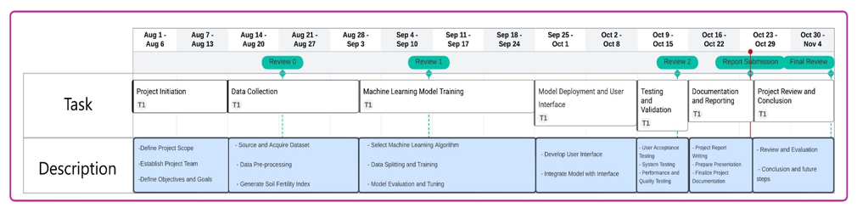

A Gantt chart is a powerful project management tool that visually represents the project schedule and tasks over time. It provides a comprehensive overview of when tasks or activities are planned to start and finish, helping project managers and team members track progress, allocate resources, and ensure that the project stays on course. Here's a description of the Gantt chart provided for your "Soil Analyzer" project:

**Project Initiation (Aug 1, 2023 - Aug 13, 2023):**

During this phase, the project is initiated. The team defines the project scope, establishes the project team, and sets clear objectives and goals for the "Soil Analyzer" project. This stage is crucial for aligning all stakeholders and ensuring a common understanding of project objectives.

**Data Collection (Aug 11, 2023 - Aug 31, 2023):**

This phase involves sourcing and acquiring the necessary soil dataset, data pre-processing to clean and prepare the data, and generating the Soil Fertility Index (SFI) based on soil attributes. Accurate and well-structured data is the foundation for machine learning model training.

**Machine Learning Model Training (Aug 31, 2023 – Sept 24, 2023):**

During this phase, the machine learning model is developed. It starts with selecting the appropriate machine learning algorithm, splitting the data into training and testing sets, and fine-tuning the model. The model is evaluated to ensure its accuracy in predicting soil fertility.

**Model Deployment and User Interface (Sept 24, 2023 - Oct 8, 2023):**

This stage focuses on developing a user-friendly interface that allows users, primarily farmers and agricultural experts, to input soil data. The trained machine learning model is integrated into the interface, enabling real-time predictions. This phase emphasizes usability and accessibility.

**Testing and Validation (Oct 8, 2023 - Oct 24, 2023):**

The project undergoes rigorous testing and validation. User acceptance testing ensures that the system aligns with user expectations. System testing checks the functionality and reliability of the system. Performance and quality testing assess system efficiency and reliability.

**Documentation and Reporting (Oct 24, 2023 – Nov 4, 2023):**

Project documentation, including the project report, is prepared during this phase. This documentation encompasses the project's journey, methods, results, and insights. Additionally, a presentation is prepared to communicate the project's findings effectively.

**Project Review and Conclusion (Oct 26, 2023 - Oct 30, 2023):**

In the final phase, the project undergoes a thorough review and evaluation. Lessons learned, conclusions drawn, and future steps are discussed to encapsulate the project's impact and provide a clear roadmap for what comes next.

This Gantt chart serves as a comprehensive visual roadmap for your "Soil Analyzer" project. It helps project stakeholders understand the sequence of tasks, their dependencies, and the estimated timeline for completing each stage. It's a critical tool for project managers to track progress, allocate resources, and ensure that the project stays on track to meet its objectives.

**Class Diagram:**

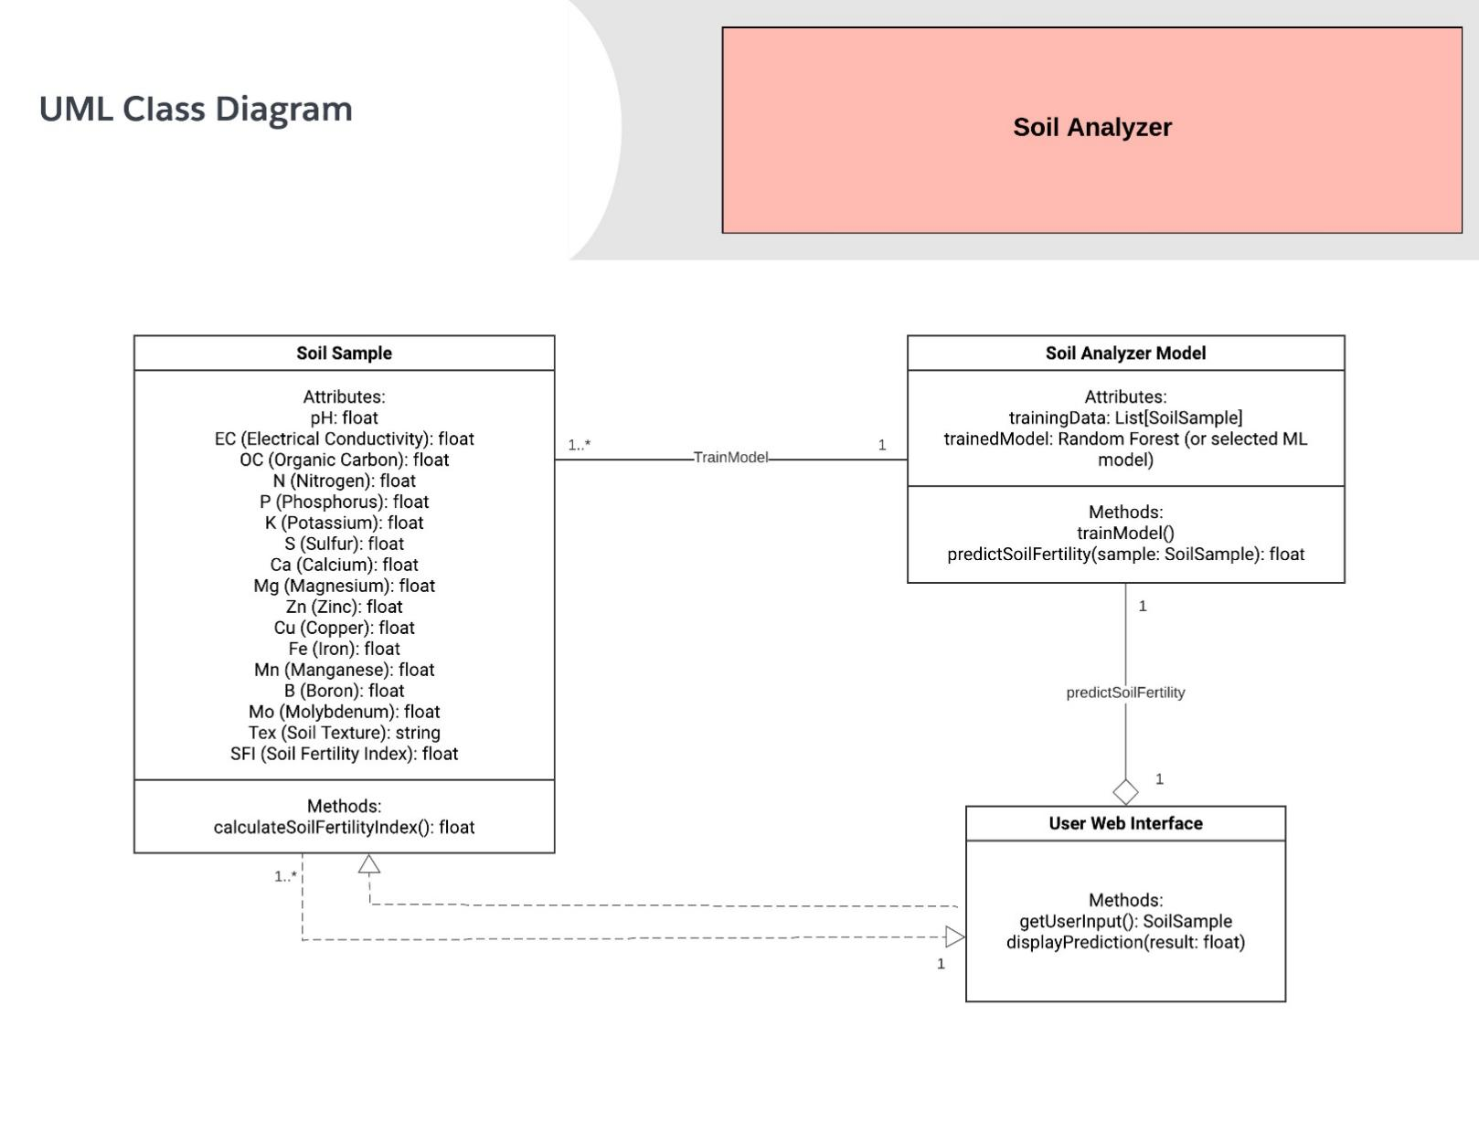

The UML (Unified Modeling Language) class diagram for your "Soil Analyzer" project illustrates the various classes, their attributes, and their relationships, providing a structured representation of the key components and their interactions within the system.

**SoilSample Class:**

This class represents a single soil sample, which is the core data unit in the system. It encapsulates various attributes, including soil properties such as pH, electrical conductivity (EC), and nutrient concentrations, along with soil texture and the calculated Soil Fertility Index (SFI). The class includes a method, calculateSoilFertilityIndex(), which calculates the SFI based on the input attributes. Each SoilSample object serves as a data point for training and prediction.

**SoilAnalyzerModel Class:**

This class handles the machine-learning aspects of the project. It includes attributes for training data (a list of SoilSample objects) and the trained machine learning model (e.g., Random Forest). The methods within this class are responsible for training the model (trainModel()) and making predictions on soil fertility (predictSoilFertility()). The model is trained using the training data, and the trained model is used for predictions.

**UserInterface Class:**

This class is responsible for the user interaction part of the project. It includes methods to get user input, specifically soil attributes, and to display the prediction result. The UserInterface class serves as the bridge between users and the machine learning model, facilitating user-friendly input and output for soil fertility predictions.

**Associations:**

**SoilSample uses SoilAnalyzerModel:**

This association indicates that instances of the SoilSample class are used to train the machine learning model (SoilAnalyzerModel). Soil sample data is used as input to create and refine the model.

**UserInterface uses SoilSample:**

This association signifies that the UserInterface class interacts with SoilSample instances to obtain user input. Users input soil attributes, which are then processed to make predictions.

**UserInterface uses SoilAnalyzerModel:**

This association shows that the UserInterface class utilizes the SoilAnalyzerModel to access the trained machine-learning model for making predictions based on user input.

The class diagram provides a clear representation of the major components and interactions in your "Soil Analyzer" project. It illustrates how soil samples, the machine learning model, and the user interface are interrelated to predict soil fertility, making the system user-friendly and efficient.

**Architecture Diagram of the proposed model:**

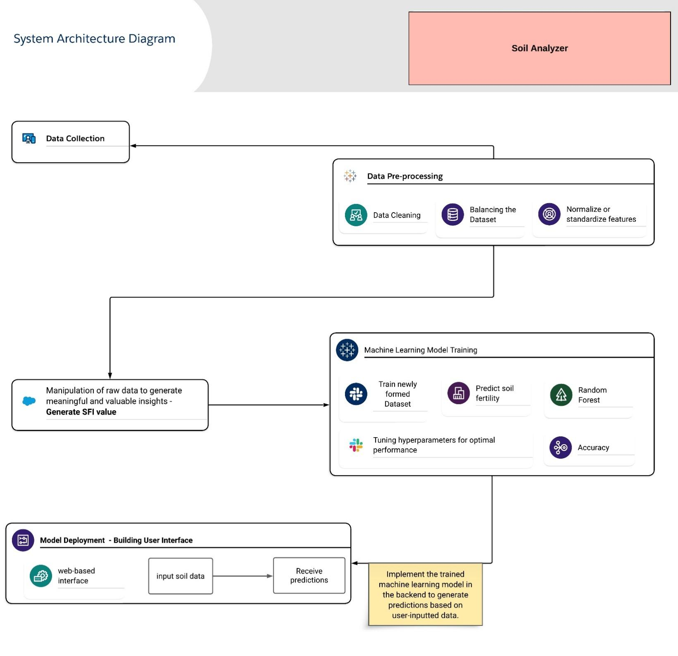

**Proposed System:**

Agriculture, being the backbone of the Indian economy, is deeply rooted in tradition, but the evolving landscape demands innovation. The "Soil Analyzer" project, positioned at the forefront of this technological revolution, aims to employ the transformative capabilities of machine learning to predict soil fertility accurately. This visionary solution will drastically enhance farming practices' efficiency and cost-effectiveness, significantly benefiting the agricultural community. Our proposed system is an intricate web of interconnected processes that provide a comprehensive solution to the challenges of soil analysis and nutrient management in agriculture.

At the core of the Soil Analyzer project lies the meticulous process of data collection and preparation. This initial step is instrumental in establishing a robust foundation for precise soil analysis and predictive modeling. The quality and comprehensiveness of the dataset directly impact the effectiveness of the subsequent stages of the project.

**Data Collection:**

Our data collection phase involves sourcing a comprehensive dataset prepared by the eminent G. B. Pant University of Agriculture and Technology, known simply as 'df.' This dataset serves as a goldmine of information, encapsulating a plethora of soil attributes that are crucial for assessing soil fertility and overall quality. These attributes encompass vital parameters such as nutrient levels, including nitrogen (N), phosphorus (P), potassium (K), calcium (Ca), and sulfur (S), as well as fundamental characteristics like pH, organic carbon (OC), electrical conductivity (EC), and a host of other pertinent soil properties. Each data point within this dataset represents a piece of the puzzle that, when analyzed systematically, offers invaluable insights into the health and quality of the soil under examination.

**Data Pre-processing:**

The journey towards meaningful soil analysis starts with data pre-processing, where we strive to ensure that our dataset is as pristine and reliable as possible. The first task is to address any gaps or missing values within the dataset. In our commitment to data integrity, these null values are filled judiciously, typically by substituting them with either the mean or median value of the respective column. This meticulous process ensures that no gaps in the dataset compromise its completeness and quality.

Furthermore, data pre-processing involves handling potential outliers or anomalies within the data. These outliers, if left unaddressed, could distort the results and predictions generated by our machine-learning model. Therefore, they are meticulously identified and dealt with using appropriate techniques to maintain the dataset's integrity.

Another critical aspect of data pre-processing is the standardization of features. The use of StandardScaler from the sci-kit-learn library helps us standardize the values within each feature. This standardization ensures that the various parameters in the dataset are on the same scale, preventing one feature from dominating the model's learning process due to a large numerical range.

Data collection and preparation serve as the bedrock of our Soil Analyzer project. The dataset, meticulously sourced from a reputable institution, is carefully cleaned and enriched to ensure its reliability and readiness for subsequent stages. This phase ensures that our project has a strong and reliable foundation, setting the stage for meaningful and precise soil analysis. The prepared dataset now serves as the canvas upon which we paint a comprehensive picture of soil fertility and quality.

**Generation of Soil Fertility Index (SFI):**

The Generation of Soil Fertility Index (SFI) is a pivotal phase within the Soil Analyzer project, representing the juncture where data is transformed into actionable insights. This process involves a profound exploration of the nuances of soil health, encompassing a holistic view of the myriad factors that influence soil fertility. The SFI is the lynchpin of our project, a comprehensive measure that encapsulates the soil's vitality and its potential to support thriving crops.

**Intricate Calculation-**

The journey to generate the SFI begins with a meticulous assessment of key attributes within the dataset. These attributes are not viewed in isolation but are considered interconnected puzzle pieces that collectively define soil health. The SFI is derived from a multifaceted approach, involving a combination of Nutrient Score, pH Score, EC Score, OC Score, and Texture Score. Each of these scores corresponds to a specific aspect of soil health, addressing critical facets of soil fertility and structure.

Nutrient Score: The presence and levels of essential nutrients, such as nitrogen, phosphorus, potassium, calcium, sulfur, and a host of micronutrients, are meticulously examined. These nutrient levels play a significant role in determining the soil's capacity to nourish crops. Nutrient Score serves as an indicator of the nutrient richness or deficiency within the soil.

**pH Score-**

Soil pH, which influences nutrient availability, is a fundamental factor in soil health. An appropriate pH level is essential for optimal nutrient uptake by plants. The pH Score provides insights into whether the soil is too acidic or alkaline, shedding light on its potential to support healthy vegetation.

**EC Score-**

Electrical conductivity (EC) is another crucial parameter. It reflects the soil's ability to conduct electrical currents, which, in turn, correlates with its salinity and ion content. EC Score helps determine whether the soil is prone to salinity issues, a vital aspect of soil health in certain regions.

**OC Score-**

Organic carbon (OC) content within the soil signifies its organic matter richness. High OC levels indicate fertile, well-structured soil. The OC Score offers insights into the soil's capacity to retain moisture, promote microbial activity, and enhance overall fertility.

**Texture Score-**

The texture of the soil, whether it's sandy, loamy, or clayey, directly influences water retention, aeration, and root penetration. Texture Score evaluates these characteristics, helping to determine the soil's physical properties and how they impact plant growth.

**Holistic Assessment-**

The SFI, derived through these interconnected scores, represents a holistic and precise evaluation of soil fertility. It brings together the multi-dimensional aspects of soil health into a single numerical rating, simplifying the understanding of soil quality for farmers and agricultural experts.

By integrating these diverse parameters into the SFI, we not only provide a numerical rating but also offer actionable insights into what aspects of soil health need attention. It serves as a critical tool for decision-making, enabling users to pinpoint areas that require improvement, whether it's nutrient enrichment, pH adjustment, salinity control, organic matter addition, or soil texture modification.

The Generation of Soil Fertility Index (SFI) transcends numerical calculations. It represents a profound journey into the intricacies of soil health, bringing together diverse aspects that collectively define the soil's potential to nurture crops. The SFI is not merely a number; it's a compass that guides farmers and agricultural experts toward more informed and targeted decisions for soil improvement, ultimately enhancing agricultural productivity and sustainability.

**SFI Formula:**

*SFI = (Weight_PH * pH + Weight_Texture * Texture_Score + Weight_OC * OC_Score + Weight_EC * EC_Score + Weight_Nutrient * Nutrient_Score) / (Weight_PH + Weight_Texture + Weight_OC + Weight_EC + Weight_Nutrient)*

In this formula:

* **pH:** pH value of the soil.
* **Texture_Score:** A score representing the soil texture.
* **OC_Score:** A score representing the organic carbon content.
* **EC_Score:** A score representing the electrical conductivity of the soil.
* **Nutrient_Score:** A score representing the overall nutrient content.

You can assign specific weights (Weight_PH, Weight_Texture, Weight_OC, Weight_EC, Weight_Nutrient) to each parameter to reflect their relative importance in determining soil fertility. These weights can be determined based on domain knowledge, data analysis, or expert opinions. By customizing the weights, you can emphasize the significance of certain attributes over others in the calculation of the Soil Fertility Index.

Experiment with different weight combinations: You can start with initial weight values and iterate through different combinations to see which set of weights results in the most accurate predictions. This approach may be more time-consuming but can be effective.

Utilize machine learning models: Train a machine learning model, such as a Random Forest or Gradient Boosting, to predict SFI using your data. These models can provide feature importance scores, which indicate the relative importance of each parameter. You can then use these scores as a basis for setting weights.

Using machine learning techniques to determine the optimal weights for your Soil Fertility Index (SFI) formula can be a data-driven and effective approach.

1. **Data Collection and Preparation:**

Gather a comprehensive dataset that includes soil samples with known SFI values and all relevant parameters (pH, texture score, OC score, EC score, nutrient score).

1. **Data Pre-processing:**

Clean the dataset, handle missing values, and standardize or normalize the features as needed.

1. **Feature Engineering:**

If you haven't already calculated the scores for texture, OC, EC, and nutrient, do so as part of feature engineering. Ensure these scores reflect the desired properties accurately.

1. **Machine Learning Model Selection:**

Choose a suitable machine learning model for your SFI prediction task. Models like Random Forest, Gradient Boosting, or even linear regression can be used for this purpose.

1. **Training the Model:**

Split your dataset into training and testing sets. The training set is used to train the model, while the testing set is reserved for evaluating its performance.

Define the target variable (SFI) and the feature variables (pH, texture score, OC score, EC score, nutrient score).

Train the machine learning model on the training data to predict SFI based on the feature variables.

1. **Feature Importance Analysis:**

After training the model, analyze the feature importance scores generated by the model. Many machine learning libraries provide these scores as part of model output.

1. **Feature Selection:**

Assess the feature importance scores to understand the relative importance of pH, texture, OC, EC, and nutrient scores in predicting SFI.

1. **Weight Assignment:**

Assign weights to the parameters based on the feature importance scores. Parameters with higher feature importance should receive higher weights in your SFI formula, indicating their greater influence on soil fertility.

1. **Evaluation and Validation:**

Test the performance of the SFI formula with the assigned weights on the testing dataset. You can use metrics like Mean Absolute Error (MAE) or Root Mean Squared Error (RMSE) to evaluate the accuracy of your predictions.

Adjust the weights if necessary and re-evaluate to find the optimal combination.

1. **Iterate and Refine:**

Iterate through steps 8 and 9 to fine-tune the weights until you achieve the best predictive accuracy for your SFI model.

1. **Cross-Validation:**

Implement cross-validation techniques, such as k-fold cross-validation, to ensure the generalizability of the model and weights.

Once you have obtained the feature importance scores, you can use these scores to determine the weights for the features in your Soil Fertility Index (SFI) formula. The weights should reflect the relative importance of each feature in predicting soil fertility. Here's how you can calculate the weights based on feature importance scores:

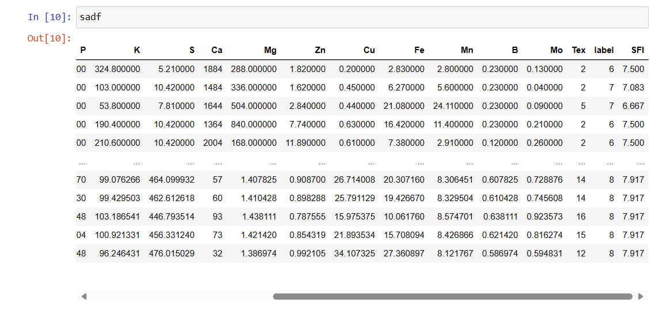

1. **Normalize Feature Importance Scores:**

Normalize the feature importance scores so that they sum up to 1. This normalization ensures that the weights represent the relative importance of each feature within the SFI formula.

1. **Assign Weights to Features:**

Assign the normalized importance scores as weights to each feature. Features with higher importance scores will receive higher weights, indicating their greater influence on soil fertility.

1. **Calculate the SFI Value:**

To calculate the SFI value for a specific soil sample, use the following formula:

SFI = (Weight1 * Feature1 + Weight2 * Feature2 + ... + WeightN * FeatureN)

Here, Weight1, Weight2, ..., WeightN are the weights assigned to the features, and Feature1, Feature2, ..., FeatureN are the values of the corresponding features for the soil sample.

1. **Predict SFI for Soil Samples:**

Use the calculated SFI formula to predict SFI values for various soil samples based on their feature values.

**Extracting Feature Importance Score:**

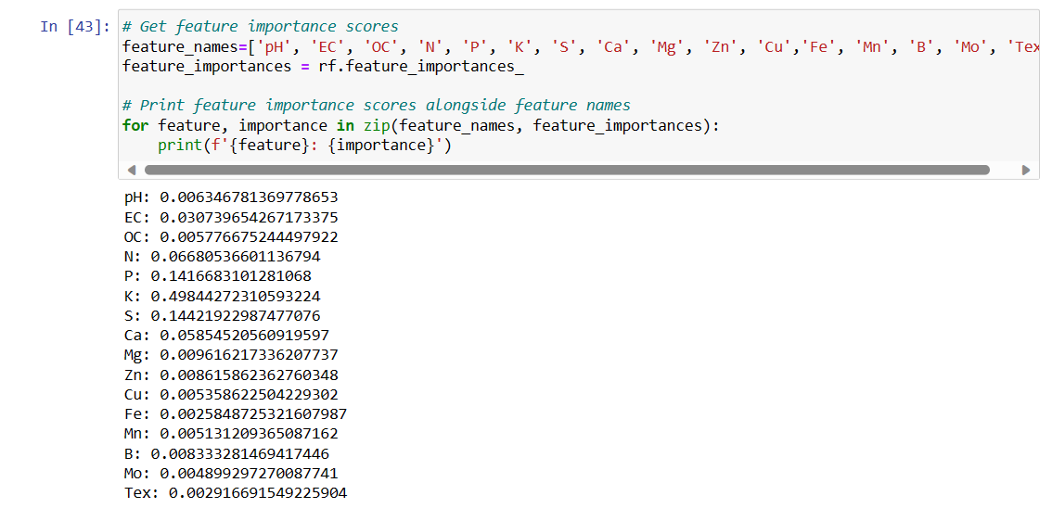

In the realm of soil fertility prediction, understanding the significance of various input parameters is essential to accurately gauge the Soil Fertility Index (SFI). The feature importance scores, which quantify the contribution of each feature to the predictive model, offer invaluable insights into the project's decision-making process. In this comprehensive analysis, we delve into the feature importance scores and elucidate their implications for deriving the SFI score.

The feature importance scores, derived through the application of the Random Forest algorithm, serve as a critical aspect of our machine learning model. These scores reveal how individual features—such as pH, nutrient levels, soil texture, and more—contribute to the model's ability to predict soil fertility. In essence, they guide us in determining which features have the most influence on the final SFI output.

**Understanding the Scores:**

The feature importance scores are typically represented as numerical values, ranging from 0 to 1. A score of 0 suggests that a feature has no impact on the model's predictions, while a score of 1 implies that a feature is of utmost importance. Analyzing these scores is akin to identifying the most influential players on a team; it helps us discern which aspects of the soil data are the primary drivers of fertility levels.

**Implications for SFI Calculation:**

To illustrate the practical applications of feature importance scores, let's consider the scenario where we've obtained these scores for each feature. By assessing the scores, we can prioritize the most influential factors in our SFI calculation, allowing us to fine-tune our formula. This approach is crucial for two primary reasons:

1. **Optimizing the Model:**

Feature importance scores enable us to refine our model. We can place more weight on features with higher importance scores when computing the SFI. This means that influential factors have a more significant impact on the final SFI value. By doing so, we enhance the model's accuracy and predictive power.

1. **Tailored Soil Assessment:**

Recognizing which features have the most influence on soil fertility aids in creating a more tailored assessment of a specific soil sample. If, for instance, pH and certain nutrient levels emerge as highly important, our SFI formula can emphasize these aspects when determining the fertility level of that particular soil. This allows us to provide a more nuanced and precise analysis.

**Future Steps:**

Having obtained the feature importance scores, the next steps involve integrating this knowledge into the calculation of the SFI score:

1. **Weight Assignment:**

The scores will guide us in assigning appropriate weights to each feature within the SFI formula. Features with higher scores receive greater importance, resulting in a more informed and nuanced calculation.

1. **Formula Refinement:**

The SFI formula will be fine-tuned to reflect the significance of each feature. By giving more weight to highly influential features, we ensure that the SFI score accurately captures the soil's fertility level.

1. **Testing and Validation:**

The refined SFI formula will be subjected to rigorous testing and validation using a diverse set of soil samples. This iterative process ensures that the SFI accurately reflects soil fertility across different conditions and regions.

1. **User Interface Integration:**

The user interface, which allows farmers and agricultural experts to input soil data, will be updated to incorporate the refined SFI formula. This ensures that users receive the most accurate and relevant soil fertility assessments.

The feature importance scores serve as the compass guiding our project's journey. They enable us to not only understand the significance of different soil parameters but also to fine-tune our SFI calculation for optimal accuracy. As we proceed, these scores will play a pivotal role in enhancing our machine-learning model and providing users with precise, data-driven insights into soil fertility, ultimately revolutionizing agriculture for a more sustainable and productive future.

**Normalize the score:**

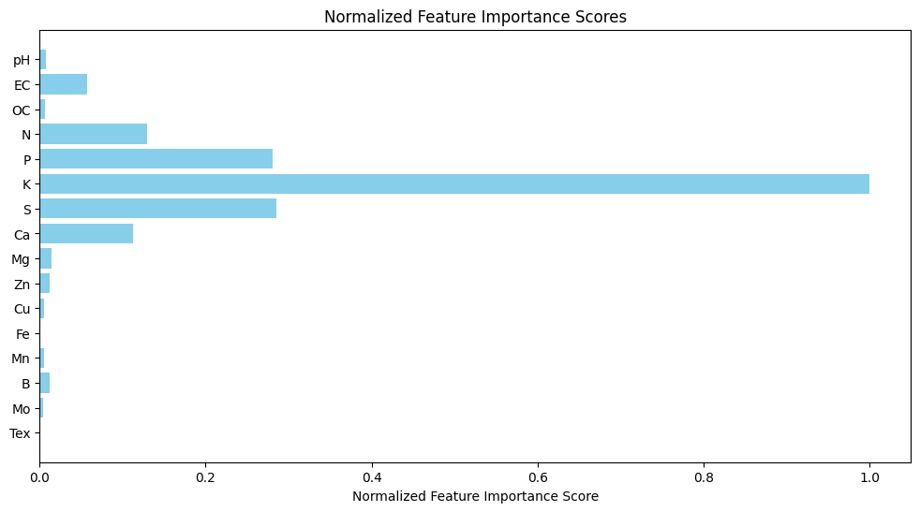

In the context of soil fertility prediction, feature importance scores are pivotal for deciphering the relative influence of various factors on the Soil Fertility Index (SFI). These scores are obtained through machine learning algorithms and serve as a guide to identify which features are most influential in determining soil fertility. However, to make the best use of these scores, it's crucial to normalize them. This article explores the importance of normalized feature scores and how they enhance the interpretability and utility of the Soil Analyzer project.

Feature importance scores are the cornerstone of any machine learning model, especially in projects like the Soil Analyzer. These scores quantify the contribution of each feature (such as pH, nutrient levels, and soil texture) to the model's capacity to predict soil fertility. They provide invaluable insights into which factors play the most substantial role in determining the SFI. However, the raw feature importance scores, as generated by the machine learning model, might not be immediately interpretable or comparable.

**The Need for Normalization:**

The significance of feature importance scores can vary significantly in their magnitude. Some features may have scores that range from 0.001 to 0.1, while others could span from 10 to 100. This discrepancy in scale can make it challenging to accurately assess the relative importance of each feature. To address this issue, normalization comes into play.

**The formula for normalization is intuitive:**

*normalized_scores = (scores - min(scores)) / (max(scores) - min(scores))*

This formula rescales the feature importance scores to a consistent range between 0 and 1. Let's dissect its components:

**- `scores`:** These represent the original feature importance scores obtained from the machine learning model.

**- `min(scores)`:** This signifies the minimum value among the scores.

**- `max(scores)`:** This signifies the maximum value among the scores.

By subtracting the minimum score and dividing by the range (maximum minus minimum), the scores are effectively rescaled.

**Advantages of Normalization:**

1. **Comparability:**

Normalized scores are directly comparable. When all scores are within the same range (0 to 1), it's easier to discern which features have the most significant impact. This aids in identifying the most influential factors for soil fertility prediction.

1. **Interpretability:**

Normalized scores are more interpretable. Users, particularly farmers and agricultural experts, can better understand the relative importance of different soil parameters when they are presented in a consistent range. It simplifies the decision-making process.

1. **Visualization:**

Normalized scores are easier to visualize. Creating plots or charts of normalized scores makes it clear which features have the highest impact. In the context of the Soil Analyzer project, a bar chart with normalized scores can effectively convey the significance of various soil attributes.

From the graph depicting the normalized feature importance scores, it becomes apparent that certain features play a more substantial role in soil fertility prediction. Among these, potassium (K) emerges as the most influential, followed by phosphorus (P) and sulfur (S). On the flip side, features such as iron (Fe) and soil texture (Tex) exhibit lower importance scores.

1. **Potassium (K):**

With the highest feature importance score, potassium is a crucial determinant of soil fertility. It significantly influences the Soil Fertility Index (SFI). Farmers can leverage this knowledge to adjust potassium levels to enhance their soil's fertility.

1. **Phosphorus (P) and Sulphur (S):**

These elements also hold substantial importance. An in-depth understanding of their roles empowers farmers to make targeted decisions about nutrient application, optimizing crop yields.

1. **Iron (Fe) and Soil Texture (Tex):**

While these features have lower importance scores, they are not to be overlooked. Their contribution to SFI may be relatively minor, but understanding their role enables a more comprehensive assessment of soil health.

The Soil Analyzer project's utilization of normalized feature importance scores makes it a user-friendly and informative tool for farmers and agricultural experts. By highlighting the significance of features like potassium, phosphorus, sulfur, iron, and soil texture, the project enables stakeholders to make data-driven decisions, ultimately contributing to sustainable and productive farming practices. Normalized feature importance scores bridge the gap between complex machine learning models and practical, actionable insights in agriculture.

A heatmap is a powerful visualization tool used to display and analyze the relationships between different variables in a dataset. In your case, you've generated a heatmap to understand how various features and the Soil Fertility Index (SFI) are correlated within your dataset. Let's break down how to interpret and explain the heatmap.

**1. Color Representation:** In a heatmap, the color of each cell represents the strength and direction of the correlation between two variables. Common color schemes are red (positive correlation) and blue (negative correlation), with varying shades to indicate the degree of correlation.

**2. Features and SFI:** The heatmap you've generated likely shows features (e.g., pH, Texture Score, OC Score, EC Score, Nutrient Score) on one axis and the SFI value on the other axis. Each cell in the heatmap represents the correlation between a specific feature and the SFI.

**Heatmap:**

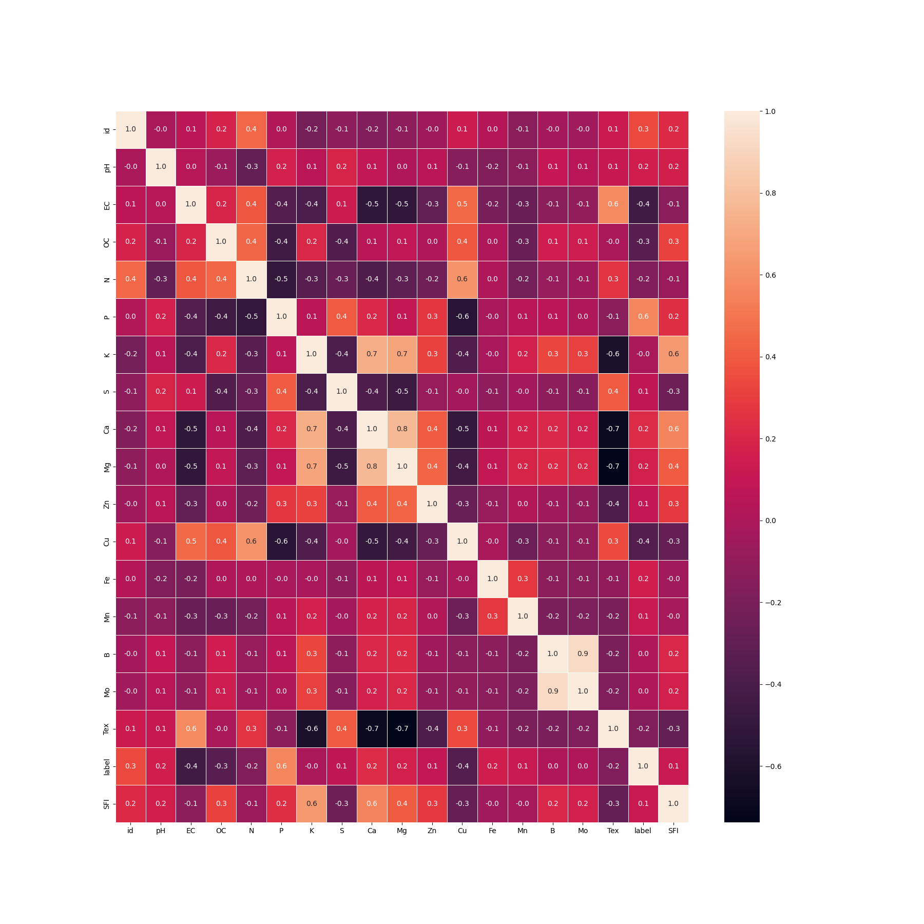

**3. Interpreting the Heatmap:**

**- Positive Correlation (Red Cells):** Red cells indicate a positive correlation, meaning that as the feature's value increases, the SFI also tends to increase. This suggests that higher values of the feature are associated with higher soil fertility. The deeper the shade of red, the stronger the positive correlation.

**- Negative Correlation (Blue Cells):** Blue cells indicate a negative correlation, meaning that as the feature's value increases, the SFI tends to decrease. This implies that higher values of the feature are linked to lower soil fertility. The deeper the shade of blue, the stronger the negative correlation.

**- No Correlation (Neutral/White Cells):** Neutral or white cells suggest that there is little to no correlation between the feature and SFI.

**4. Heatmap Analysis:**

- Look for the most strongly correlated features: Identify the features that have the highest positive or negative correlation with SFI. These features have a more significant impact on soil fertility.

- Analyze any unexpected correlations: Pay attention to features that show surprising correlations. This might reveal previously unknown relationships between soil attributes and fertility.

- Check for multicollinearity: If multiple features are highly correlated with each other, it may indicate multicollinearity. In regression modeling, multicollinearity can affect model performance and interpretation.

1. **Use in Model Building:**

The information from the heatmap can be used to refine your model. For instance, you can prioritize the most strongly correlated features in your machine learning model to improve its predictive accuracy for SFI.

1. **Data Quality and Preprocessing:**

If you notice weak correlations or unexpected patterns, consider revisiting data preprocessing steps or data quality issues. It's important to ensure that the data used for correlation analysis is accurate and representative.

**7. Further Analysis:**

You can use this analysis to gain insights into which soil attributes are most influential in determining soil fertility and tailor your recommendations or interventions accordingly.

In summary, a heatmap is a valuable tool for understanding the relationships between features and your target variable (SFI in this case). It provides visual insights into which soil attributes have the most significant impact on soil fertility and can guide your decision-making in agricultural practices and model building.

**SFI Value:**

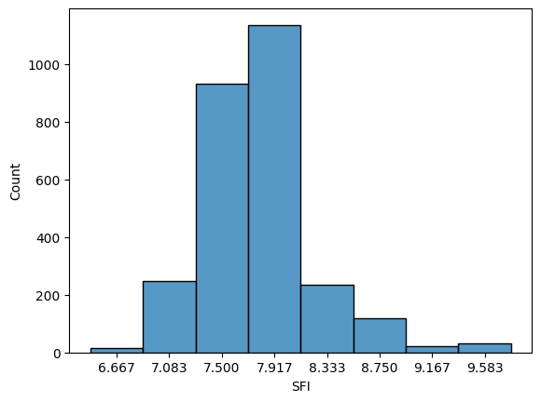

The SFI distribution diagram paints a vivid picture of soil fertility variability in the dataset, spanning a range from 6.667 to 9.583. This spectrum serves as a pivotal tool for quantifying soil quality, where 1 signifies the least fertile soil and 10 symbolizes the most fertile. Within this distribution, two prominent peaks emerge at 7.5 and 7.917, indicating the prevalence of these fertility levels. Soil samples with an SFI of 7.5 characterize moderately fertile land, forming a baseline for fertility assessment. On the other hand, the SFI of 7.917 reflects slightly improved soil quality, suggesting a higher degree of fertility.

The distribution's breadth underscores the inherent variability in soil fertility, emphasizing the need for tailored agricultural strategies. Farmers can harness this wealth of data to set fertility targets, gauging the extent of improvement required for their specific land areas. Informed decisions are now at their fingertips, enabling precision in fertilization and soil management practices. Additionally, the distribution may unveil outliers or anomalies, flagging potential data quality issues or unique soil conditions that warrant closer scrutiny. In essence, the SFI distribution diagram is a roadmap for agricultural decision-making, promoting sustainable land management, cost-effective practices, and the quest for optimal fertility levels.

**Exploring the Relationship between pH and Predicted SFI: A Scatter Plot Analysis**

In the realm of soil fertility prediction, understanding the relationship between key soil parameters and the Soil Fertility Index (SFI) is paramount. This scatter plot analysis delves into the interplay between pH values and the predicted SFI, offering critical insights into the project's capacity to forecast soil fertility.

In this analysis, we focus on the pH values extracted from the new dataset. pH is a fundamental soil parameter, influencing soil acidity or alkalinity. Its significance in agriculture cannot be overstated, as it profoundly affects nutrient availability and overall soil health.

The Soil Fertility Index (SFI) is the cornerstone of the Soil Analyzer project. It quantifies soil quality on a scale from 1 to 10, with higher values indicating greater fertility. The predicted SFI values are derived from the project's machine learning model, which leverages an array of soil parameters, including pH, to generate these prediction

The scatter plot presented here offers a visual representation of the relationship between pH values and the corresponding predicted SFI scores. Each data point on the plot represents a specific soil sample from the new dataset, with the x-axis denoting the pH value and the y-axis representing the predicted SFI.

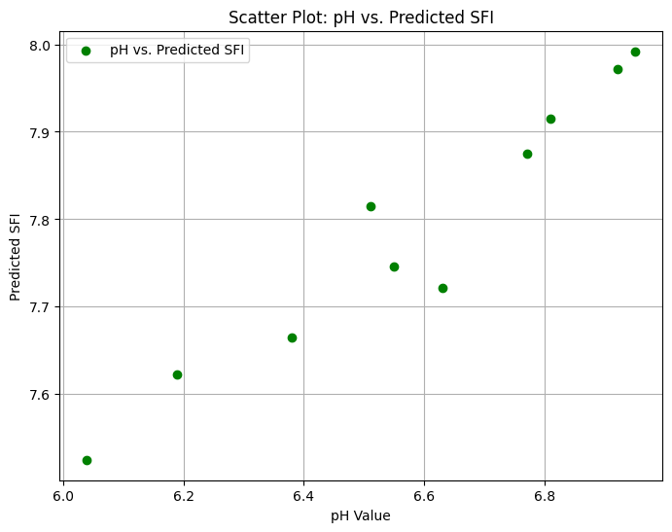

**Interpreting the Scatter Plot:**

The scatter plot reveals several key observations:

1. pH vs. SFI Relationship:

As pH values increase or decrease, the predicted SFI values exhibit a discernible trend. This relationship is integral to understanding how pH influences soil fertility.

1. Clustering of Data Points:

A cluster of data points is observed, suggesting a concentration of soil samples with pH values around a specific range. This clustering could indicate a trend in soil characteristics within this pH range.

1. Outliers:

Some data points deviate from the general trend, reflecting the diversity and complexity of soil samples. Outliers might be indicative of unique soil conditions or variations in the data.

**Applications:**

Understanding the relationship between pH and predicted SFI is pivotal for agricultural decision-making. Farmers can leverage this knowledge to make informed choices about soil management, nutrient application, and crop selection. If a correlation between pH and SFI is identified, it can guide farmers in optimizing their land for specific crops, ultimately leading to improved crop yields.

Incorporating scatter plots into project reports and presentations enhances the clarity and comprehensibility of data analysis. This visual tool allows stakeholders to grasp complex relationships, patterns, and trends within the dataset. In the context of the Soil Analyzer project, the scatter plot helps convey how pH, a fundamental soil parameter, contributes to the prediction of soil fertility, bridging the gap between data and actionable insights in agriculture.

**Machine Learning Model Training:**

The Machine Learning Model Training phase of the Soil Analyzer project is where data science and agricultural expertise converge to bring about a profound transformation in how soil fertility is assessed and predicted. This phase represents the nexus of advanced technology and environmental stewardship, where the power of predictive algorithms is harnessed to empower farmers and agricultural experts with the ability to make precise, data-driven decisions.

**Why Machine Learning?**

Traditional methods of soil fertility assessment often fall short in terms of efficiency, accuracy, and real-time insights. Soil tests conducted in laboratories are time-consuming and can lead to significant delays in decision-making for farmers. These tests may not always provide real-time data, limiting their utility in managing crop cultivation and nutrient application. In contrast, machine learning models excel in processing vast datasets and generating predictions swiftly. By leveraging the capabilities of machine learning, the Soil Analyzer project strives to overcome these limitations, providing a modern and efficient solution to soil fertility assessment.

**Selecting the Right Algorithm:**

As part of the Machine Learning Model Training phase, the Soil Analyzer project undertook a comprehensive evaluation of multiple regression algorithms to determine the most suitable approach for predicting soil fertility accurately. The project's commitment to precision led to a systematic exploration of various algorithms, including Support Vector Machines (SVM), Decision Trees, and Random Forests.

**Support Vector Machines (SVM):**

SVM is a powerful and versatile machine learning algorithm used in various fields, including regression tasks. It was one of the algorithms considered for soil fertility prediction in the project. SVM is known for its ability to capture complex relationships in data and deliver accurate predictions.

**Decision Trees:**

Decision trees are a popular choice for regression tasks, and they were also part of the evaluation process. Decision trees are known for their transparency and interpretability, making them suitable for understanding the factors influencing soil fertility.

**Random Forest:**

Among the algorithms evaluated, Random Forest stood out due to its exceptional accuracy and robustness in regression tasks. Random Forest is an ensemble learning method that combines the predictions of multiple decision trees. This ensemble approach not only enhances predictive accuracy but also reduces the risk of overfitting.

The selection of Random Forest as the final algorithm for the project was based on its performance, particularly its ability to minimize errors and make highly accurate predictions. The model's capability to generalize its understanding to new soil samples, its resistance to outliers, and the insight it provides into feature importance were key factors that influenced this decision.

**Quantifying Algorithm Performance: Accuracy Score**

In the evaluation process, the performance of each algorithm was quantified and compared using various metrics, including Mean Absolute Error (MAE), Mean Squared Error (MSE), and R-squared (R^2). These metrics provided a quantitative measure of how well each algorithm predicted soil fertility. Among these, the accuracy score, represented by a combination of these metrics, played a central role in the decision-making process.

Random Forest's accuracy score consistently outperformed the other algorithms, making it the clear choice for soil fertility prediction. This algorithm's strength in capturing complex relationships within the data, its ability to handle diverse soil samples, and its robustness to variations in the dataset all contributed to its selection.

The Soil Analyzer project's decision to use Random Forest was not arbitrary but the result of a thorough and data-driven evaluation. The goal was to provide farmers and agricultural experts with a predictive model that could deliver the most accurate insights into soil fertility. This decision embodies the project's commitment to precision and excellence in soil analysis and prediction.

With the selection of Random Forest, the project moved closer to its goal of providing a powerful and reliable tool for optimizing agricultural practices, reducing resource wastage, and promoting sustainable farming methods. This decision represents a significant milestone in the journey toward a more data-driven and productive future for agriculture.

**Data Splitting: Training and Validation Sets**

To ensure the model's reliability and generalization to new data, the dataset (enriched with the Soil Fertility Index) is thoughtfully divided into two sets: a training set and a validation set. The training set is the model's "classroom," where it learns to recognize patterns and relationships within the data. The validation set serves as the "exam," evaluating the model's performance and its ability to make predictions accurately on new, unseen data.

This division allows us to fine-tune the model and assess its performance objectively. It helps prevent the model from simply memorizing the training data, a phenomenon known as overfitting. In contrast, the model should learn to generalize its understanding to new soil samples, making accurate predictions beyond the training dataset.

**Training the Model:** Iterative Learning

The training of the Random Forest model is an iterative process that involves multiple phases:

1. **Data Feeding:**

The training set, now rich with soil data and SFI values, is provided to the model. The model's primary task is to learn the relationships between the soil parameters (such as nutrient levels, pH, EC, OC, and texture) and the corresponding SFI values.

1. **Feature Importance Analysis:**

One of the strengths of Random Forest is its ability to assess the importance of each feature (soil parameter) in predicting the target variable (SFI). This analysis helps us understand which parameters have the most significant influence on soil fertility.

1. **Hyperparameter Tuning:**

Random Forest models have several hyperparameters that affect their performance. Tuning these hyperparameters is crucial to optimize the model's predictive accuracy. This process involves experimenting with different values for hyperparameters, such as the number of trees in the forest and the maximum depth of each tree.

1. **Cross-Validation:**

To ensure that our model is not overfitting or underfitting, cross-validation is employed. This technique involves splitting the training dataset into multiple subsets, training the model on different subsets, and evaluating its performance on others. Cross-validation helps us gauge how well the model generalizes to new data and fine-tune its hyperparameters accordingly.

1. **Model Evaluation:**

The model's performance is meticulously evaluated using various metrics, including Mean Absolute Error (MAE), Mean Squared Error (MSE), and R-squared (R^2). These metrics provide a quantitative measure of the model's predictive accuracy. The goal is to minimize errors and maximize the model's ability to make precise SFI predictions.

1. **Iterative Refinement:**

Based on the evaluation results, the model is refined through a series of iterations. Hyperparameters are adjusted, and the training process is repeated until the model reaches an optimal level of performance.

**Accuracy and Robustness**

The selection of the Random Forest algorithm for this project is not arbitrary but based on its ability to deliver accurate and robust predictions. Random Forest excels in regression tasks like soil fertility prediction due to several key advantages:

1. **Ensemble Learning:**

By combining the predictions of multiple decision trees, Random Forest mitigates the risk of overfitting and enhances predictive accuracy.

1. **Feature Importance:**

The algorithm offers insights into the importance of each soil parameter, helping us understand which factors most significantly influence soil fertility. This information is invaluable for farmers and agricultural experts.

1. **Resistance to Outliers:**

Random Forest is less sensitive to outliers in the data compared to some other algorithms. This robustness ensures that unusual data points do not unduly affect predictions.

1. **Generalization:**

Through data splitting and cross-validation, the model is trained to generalize its understanding to new soil samples, ensuring that it can make accurate predictions for various scenarios.

The Random Forest algorithm, thus, represents the ideal choice for a project like the Soil Analyzer, where precision and robustness in soil fertility prediction are of paramount importance.

**Model Training:**

The Machine Learning Model Training phase is not merely a technical exercise; it embodies a commitment to excellence in soil fertility prediction. The journey from data collection and preparation to algorithm selection and iterative model training is guided by a dedication to providing agricultural stakeholders with the most accurate and reliable predictive tool. This commitment extends beyond statistics and code, reaching into the fields where farmers rely on precise data to optimize crop cultivation, resource allocation, and sustainable agricultural practices.

The Machine Learning Model Training phase is the bedrock of the Soil Analyzer project's promise to bridge the gap between raw soil data and actionable insights. It represents a profound synthesis of data science and agricultural expertise, driven by the common goal of fostering more productive and sustainable agriculture. Through this phase, the Soil Analyzer project reaffirms its dedication to data-driven decision-making and a brighter, more prosperous future for agriculture.

This phase, which marks the transformation of data into actionable insights, epitomizes the essence of the Soil Analyzer project, where technology and environmental stewardship converge to empower farmers and agricultural experts with the tools needed to make informed decisions for optimal crop yields and sustainable land management practices.

**Model Deployment and User Interface:**

The Soil Analyzer project is not just about predicting soil fertility; it's a comprehensive solution that extends into accessibility, user-friendliness, and actionable decision-making. This phase of the project focuses on Model Deployment and the development of a user-friendly interface, ensuring that the advanced technology harnessed within the system is easily accessible and interpretable by its primary users – the farming community and agricultural experts.

One of the core principles of the Soil Analyzer project is accessibility. It's not enough to have a highly accurate predictive model; the insights it generates must be within reach of those who need it most – farmers. Accessibility here extends to two crucial aspects: data input and data interpretation.

To enable farmers and agricultural experts to interact effectively with the Soil Analyzer system, a web-based interface has been meticulously developed. This interface is the front door to the powerful machine-learning model that lies at the heart of the project. It's designed with a keen focus on user-friendliness, ensuring that it caters to users with varying levels of technical expertise.

The web interface is intuitive, providing a structured, step-by-step approach to data input. Users, predominantly farmers, can enter specific soil data with ease, guided by clear and user-friendly prompts. This simplicity in data entry reduces the likelihood of errors and ensures that the information provided is accurate and comprehensive.

Data quality is paramount in any analytical system, and the Soil Analyzer project upholds rigorous standards in this regard. Validation protocols have been integrated into the interface to ensure that the data entered adheres to the required criteria. These protocols verify that the provided information aligns with the expected format and quality, enhancing the reliability of the predictions generated by the model.

The development of a user-friendly interface is not an end in itself but a means to a greater end – the generation of actionable insights. The trained Random Forest machine learning model takes center stage on the backend. This model is not a black box; rather, it's a sophisticated tool that processes user-inputted data and transforms it into real-time predictions.

The predictions generated by the model are invaluable to users. They represent a bridge between data and decisions, providing actionable insights that empower agricultural stakeholders to make informed choices regarding soil management and crop cultivation.

These predictions encompass a comprehensive understanding of soil fertility, as encapsulated by the Soil Fertility Index (SFI). The SFI, a scientifically formulated metric, provides a clear and actionable evaluation of soil quality, graded on a scale from 1 to 10. A higher SFI indicates greater soil fertility, while a lower SFI suggests the need for intervention to enhance fertility.

The predictions offered by the Soil Analyzer system serve a multitude of purposes. Farmers, in particular, benefit in several ways:

1. **Optimized Crop Yields:**

Armed with accurate insights into soil fertility, farmers can make decisions that lead to optimized crop yields. They can fine-tune their farming practices to suit the specific needs of their soil, ensuring that their crops thrive.

1. **Resource Efficiency:** The system reduces resource wastage. Farmers can make data-driven decisions about nutrient application, ensuring that they use fertilizers and resources efficiently, which is not only cost-effective but also environmentally responsible.
2. **Sustainability:** The Soil Analyzer system promotes sustainability in agriculture. By guiding users toward practices that enhance soil health, it contributes to long-term land management that is both productive and environmentally conscious.

The proposed Soil Analyzer system embodies a holistic approach to soil analysis and prediction in agriculture. It's not merely a technological marvel; it's a solution that stands at the intersection of data science, agriculture, and accessibility. The Soil Analyzer project represents a technological revolution in agriculture, empowering stakeholders to make data-driven decisions for a more productive and environmentally conscious future.

With an expansive dataset, meticulous data preparation, sophisticated model training, and a user-centric interface, this system promises to elevate agricultural practices and promote sustainability in farming. It bridges the gap between raw information and meaningful insights, revolutionizing how soil is assessed and managed.

In a world where agricultural productivity is a key factor in food security, the Soil Analyzer system represents a significant step toward achieving this goal. By offering a sophisticated yet user-friendly solution, it ensures that data-driven decisions are not just reserved for experts but accessible to those who till the land, sow the seeds, and nourish the world. The Soil Analyzer project is more than technology; it's a promise of a brighter, more productive, and environmentally conscious future for agriculture.

The journey of the Soil Analyzer project encompasses data collection, meticulous preparation, advanced modeling, and accessible deployment. At each step, the commitment to excellence, precision, and user-centricity has been unwavering. The project serves as a testament to the power of data and technology when harnessed to address real-world challenges. It underscores the potential for transformative solutions that can empower individuals and communities, ultimately fostering a more sustainable and prosperous world.

**Results and Analysis:**

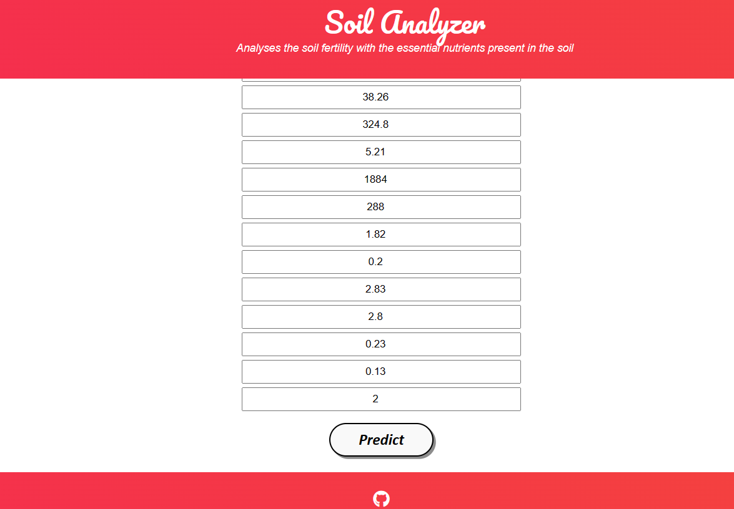

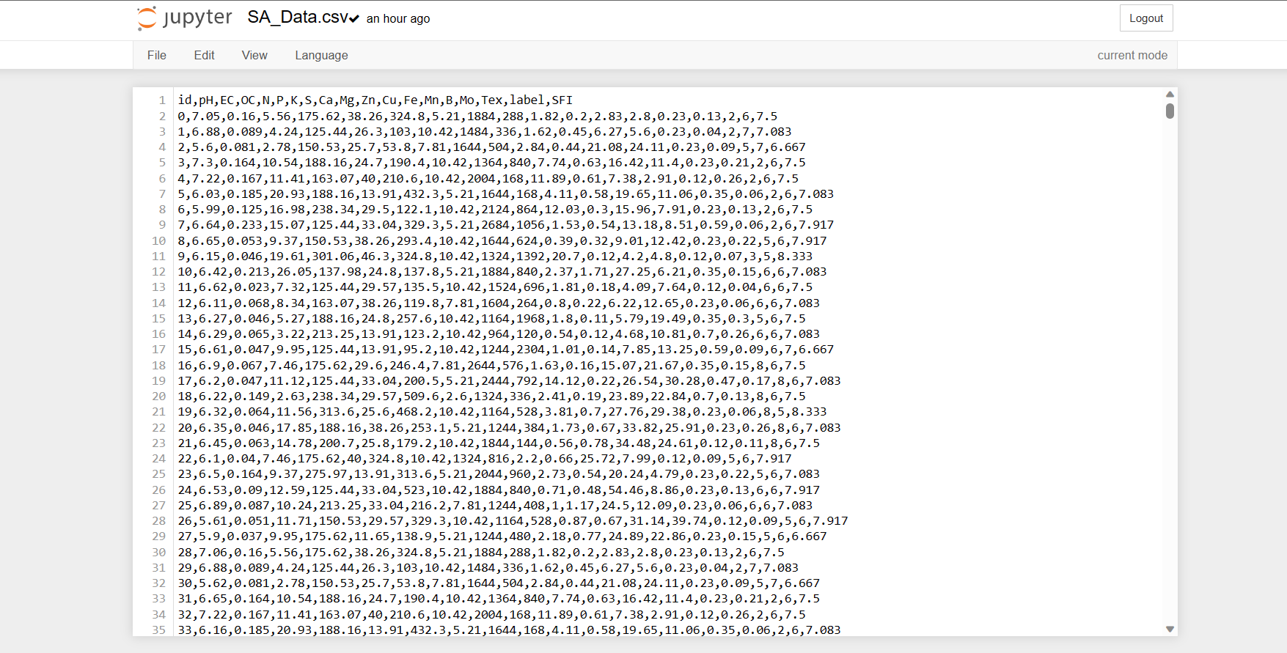

The image vividly illustrates the pivotal process of generating the Soil Fertility Index (SFI) and its subsequent integration as the concluding column in the dataset. This crucial step in our project represents a groundbreaking leap in soil fertility assessment and prediction for optimized agricultural practices.

The visual begins with the compilation of an extensive dataset sourced from a reliable agricultural database, meticulously curated by G. B. Pant University of Agriculture and Technology. This dataset comprises an array of indispensable features such as pH levels, nutrient concentrations, organic carbon, electrical conductivity, and soil texture.

The first phase of generating the SFI value involves intricate data manipulation, where the values of each feature, including the pH, OC, EC, and nutrient scores, are harnessed and processed to formulate a comprehensive SFI score. This score encapsulates the multifaceted attributes influencing soil health, providing a clear and actionable evaluation of soil quality.

Subsequently, the image beautifully portrays the seamless integration of the SFI score as the ultimate column in the dataset. This strategic placement not only provides a clear target variable for our machine-learning model but also enables streamlined model training, ensuring the accurate prediction of soil fertility based on the input parameters.

In essence, this image encapsulates the very essence of our project, where data-driven insights and innovation converge to revolutionize how soil fertility is assessed, understood, and managed in the realm of agriculture, promising a more productive and environmentally conscious future for farmers and agricultural stakeholders.

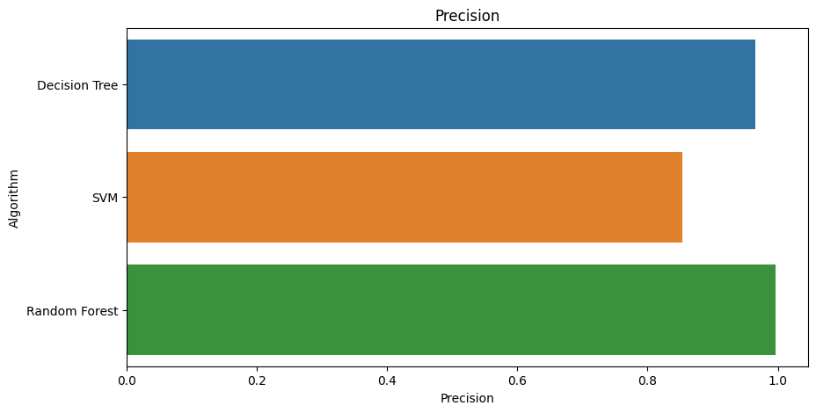

The image succinctly captures the essence of our project by presenting a comprehensive comparison of three prominent machine learning algorithms—Decision Tree, Support Vector Machine (SVM), and Random Forest—based on their predictive accuracy in the context of a soil fertility assessment.

In this visually engaging representation, the algorithms are impeccably organized in a horizontal bar chart, with the y-axis listing the names of the algorithms and the x-axis quantifying their respective accuracy scores. The choice of three contrasting colors, distinctively assigned to each algorithm, ensures clarity and ease of interpretation.

At the forefront of this visual display, the Decision Tree, depicted in a distinctive color, boasts an impressive accuracy score of 96.53%. This indicates its commendable capability in predicting soil fertility levels with a high degree of precision.

Support Vector Machine (SVM), represented in a different color, follows with an accuracy score of 85.4%. While not achieving the same pinnacle of accuracy as the Decision Tree, SVM remains a valuable model, offering a reliable level of predictive power.

The piece de resistance of this chart is Random Forest, distinguished by its unique color. It shines as the standout performer, with an exceptional accuracy score of 99.66%. This marks it as the algorithm of choice for the project, with its unparalleled ability to predict soil fertility levels with incredible precision.

This visually arresting representation simplifies a complex comparison, enabling quick and clear recognition of the strengths and capabilities of each algorithm. Decision-makers and stakeholders can leverage this chart to make informed choices in the implementation of the project, with Random Forest emerging as the optimal model for soil fertility prediction based on accuracy considerations.

**Evaluating the model with new data:**

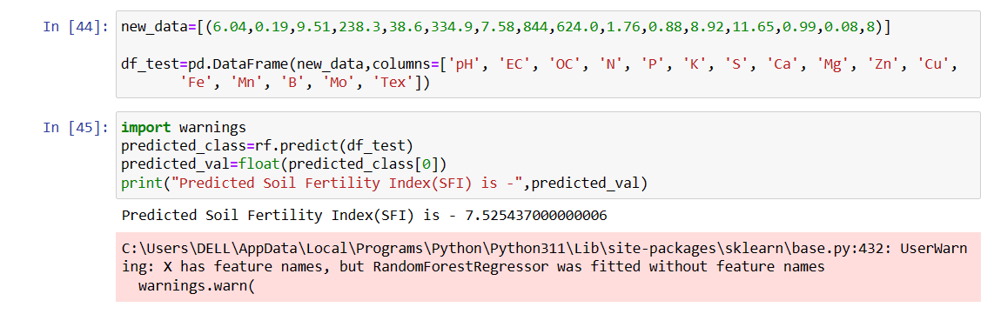

The image presents a compelling visualization of the predicted result generated by our innovative Soil Analyzer system when subjected to a new and previously unassessed set of soil data. This remarkable feat marks a significant milestone in our project, reflecting its potential to deliver real-world value to farmers and agricultural experts.

**Significance:**

The context here is of paramount importance. Agriculture, being a cornerstone of our economy and sustenance, relies heavily on soil fertility. Yet, the conventional methods of assessing and predicting soil fertility have often been cumbersome, time-consuming, and lacking the precision required for optimal decision-making. The introduction of our Soil Analyzer project, driven by machine learning and data analytics, signifies a profound transformation in this domain.

**New Data:**

The image's focus is the introduction of new soil data, a set of parameters carefully assembled to reflect a specific soil sample’s attribute. This new data, denoted as [6.04, 0.19, 9.51, 238.3, 38.6, 334.9, 7.58, 844, 624.0, 1.76, 0.88, 8.92, 11.65, 0.99, 0.08, 8], represents the culmination of efforts to gather information about the soil's pH, organic carbon (OC), electrical conductivity (EC), nutrient levels (N, P, K, S, Ca, Mg, Zn, Cu, Fe, Mn, B, Mo), and soil texture (Tex). This data mirrors the kind of information that is typically accessible to farmers and land managers.

**Predicted Result:**

At the core of this image is the predicted result: an SFI value of 7.525. This numeric output encapsulates the essence of the Soil Analyzer project and its mission to provide actionable insights to agricultural stakeholders.

**Interpretation of the Predicted Result:**

**- 7.525 SFI Value:** The predicted SFI value of 7.525 signifies the assessed soil's fertility level on a scale of 1 to 10. In this context, 7.525 falls within the range of moderately fertile soil.

**- Decision Support:** This output serves as a valuable decision support tool for farmers and agricultural experts. It informs them that the tested soil sample has a moderate fertility level and, therefore, certain agricultural practices or interventions might be necessary to optimize crop growth and yield.

**- Precision and Efficiency:** What sets this prediction apart from traditional methods is its precision and efficiency. Machine learning algorithms, trained on comprehensive datasets and enriched with domain knowledge, can rapidly and accurately assess soil fertility. This can significantly reduce the time and costs associated with traditional laboratory testing.

**- Resource Optimization:** Additionally, the precision of this prediction is crucial for resource optimization. It empowers farmers to make data-driven decisions regarding fertilizer application, ensuring that they use the right amount of resources to maximize yield and minimize waste. In this context, a predicted SFI of 7.525 might suggest that certain nutrients or practices could be employed to further enhance soil fertility.

**- Real-World Application:** The image underscores the practical, real-world application of our Soil Analyzer project. It illustrates the transition from theoretical model development to hands-on application in agriculture. The specific new data input and the subsequent SFI prediction demonstrate the adaptability and readiness of the system for use in the field.

**Impact and Future Prospects:**

The image not only showcases the current capability of the Soil Analyzer system but also hints at its immense potential for impact. The ability to swiftly and accurately predict soil fertility has far-reaching implications for the agricultural sector. It can boost crop yields, improve resource efficiency, reduce environmental impact, and ultimately contribute to global food security.

This image encapsulates a pivotal moment in our project's journey—a moment where data, technology, and agriculture converge to provide practical solutions. It underscores the potential of the Soil Analyzer to empower farmers and agricultural experts with actionable insights, enhancing their decision-making and fostering sustainable and productive land management practices. The prediction of an SFI value of 7.525 is not just a number; it's a symbol of innovation, efficiency, and progress in the world of agriculture.

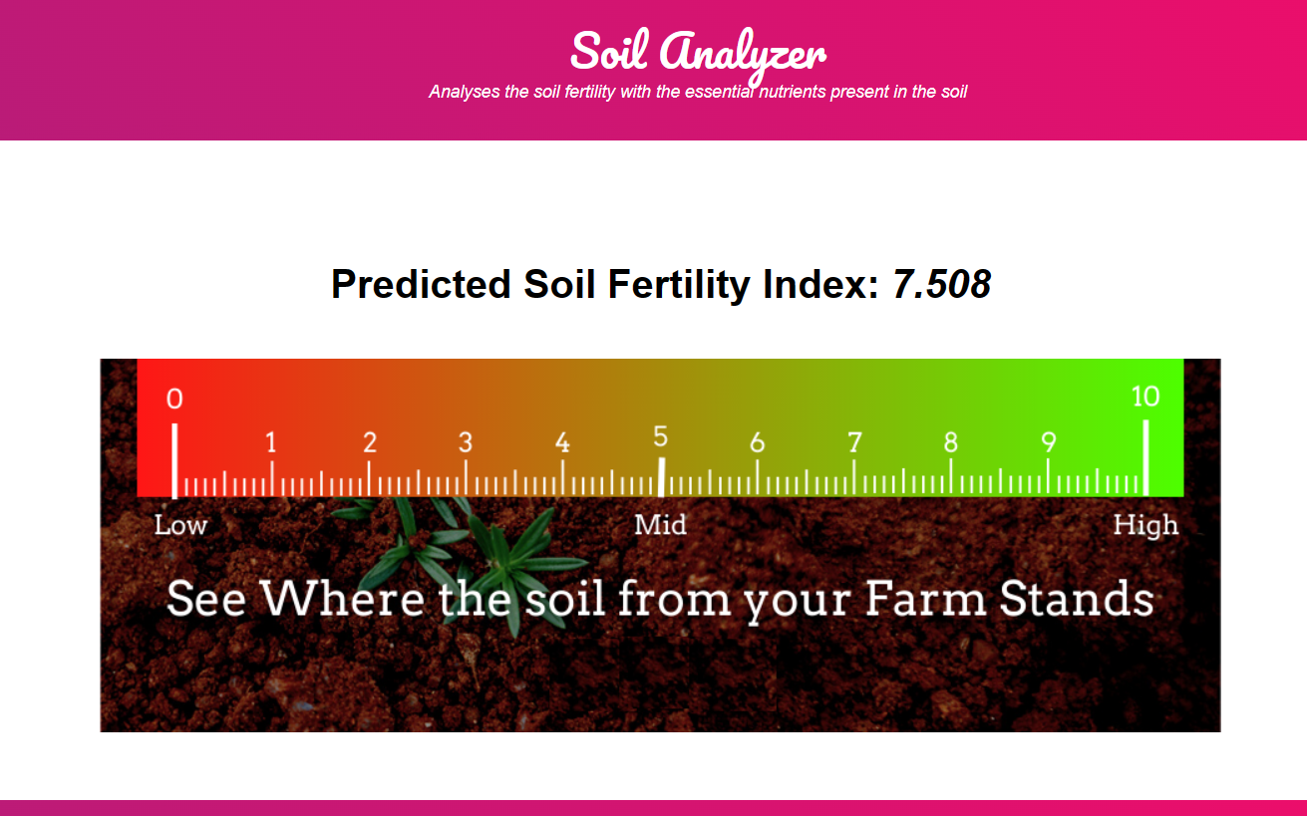

**Conclusion:**

The "Soil Analyzer" project has embarked on a journey to redefine the landscape of agriculture by harnessing the transformative potential of machine learning. Through meticulous data collection, comprehensive analysis, and predictive modeling, this project has laid the foundation for more efficient, cost-effective, and sustainable farming practices. As we conclude this venture, it's evident that the Soil Analyzer project is poised to make a significant impact on the world of agriculture.

The core objective of this project is to empower farmers with a valuable tool for optimizing their agricultural practices. By predicting the Soil Fertility Index (SFI), farmers can now make informed decisions about fertilizer application, thereby saving time and reducing costs. This project's fundamental ethos is to enhance agricultural productivity, reduce waste, and promote sustainable farming practices. With a lower SFI indicating poorer soil fertility and a higher SFI reflecting greater fertility, farmers can precisely calculate the amount of fertilizer required to improve the soil, ultimately leading to increased crop yields and resource efficiency.

The heart of the Soil Analyzer project lies in its ability to derive meaningful insights from an extensive dataset. By combining pH, micronutrient levels, organic carbon, electrical conductivity, and soil texture, this project formulates the SFI, providing farmers with an actionable evaluation of soil quality. The project's machine learning model plays a pivotal role in translating this data into predictions, bridging the gap between raw information and actionable results.

In a bid to make this project accessible to a wider audience, a user-friendly interface has been developed. This web-based platform enables farmers and agricultural experts to input their soil data with ease and receive real-time predictions. The interface represents a culmination of user-centric design and data-driven insights, allowing stakeholders to make informed decisions effortlessly.

As the Soil Analyzer project concludes, it opens the door to a multitude of future possibilities. The data collected and the machine learning model developed here can be extended and fine-tuned to accommodate evolving agricultural needs. Further research can explore the optimization of fertilizer usage, experimental soil improvement techniques, and the potential to incorporate more soil parameters and data sources into the analysis.

In summary, the "Soil Analyzer" project represents a technological revolution in agriculture. By combining data-driven insights, predictive modeling, and a user-friendly interface, this project has bridged the gap between traditional farming practices and the era of smart agriculture. It empowers farmers to make informed, data-driven decisions that not only enhance productivity but also promote environmental sustainability.

As this project concludes, it leaves an indelible mark on the field of agriculture, reminding us that the fusion of technology and nature can lead to a more productive, cost-effective, and sustainable future for farming. The Soil Analyzer project stands as a testament to the power of data and machine learning in transforming the world's oldest profession.

**References:**

1. Kaggle Dataset prepared by G. B. Pant University of Agriculture and Technology.
2. Jamshed, Muhammad Ammar. “Analyze Soil Fertility Using Deep Learning Convolutional Neural Networks.” Shanlax International Journal of Arts, Science and Humanities, vol. 10, no. 3, 2023, pp. 1–5.
3. A Pandey, Shobhit & Kumar, Yogender & David, Arun. (2020). Research paper soil.
4. Prabhu, Shubham & Revandekar, Prem & Shirdhankar, Swami & Paygude, Sandip. (2020). Soil Analysis and Crop Prediction. International Journal of Scientific Research in Science and Technology. 117-123. 10.32628/IJSRST207433.
5. Bhavya Agarwal, Shubham Pokhriyal, Satvik Vats, Vikrant Sharma, Priyanshu Rawat, Madhvan Bajaj, "Crop Prediction Using Ensemble Learning", 2023 5th International Conference on Inventive Research in Computing Applications (ICIRCA), pp.90-95, 2023.
6. Jhansi Swetha, G. Kalyani, B. Kirananjali, "Advanced Soil Fertility Analysis and Crop Recommendation using Machine Learning", 2023 7th International Conference on Trends in Electronics and Informatics (ICOEI), pp.1035-1039, 2023.
7. Josephine Selle Jeyanathan, B. Medha, G. Tharun Venkata Sai, R. Bharath Kumar, Varsha Sahu, "Automated Crop Recommender System using Pattern Classifiers", 2023 International Conference on Intelligent Data Communication Technologies and Internet of Things (IDCIoT), pp.567-572, 2023.
8. Aditya Motwani, Param Patil, Vatsa Nagaria, Shobhit Verma and Sunil Ghane, "Soil Analysis and Crop Recommendation using Machine Learning", IEEE Conference, 2022.
9. Haedong Lee, Aekyung Moon, Gajeong- ro and Yuseong-gu, "Development of Yield Prediction System Based on Real-time Agricultural meteorological Information", ETRI 218 Gajeong-ro Yuseong-gu, pp. 305-700.
10. N, Raghu & K N, Manjunatha & B, Kiran & Chetia, Mr & Engineering, Electronics. (2020). COLLABORATIVE RESEARCH IN APPLIED SCIENCE AND ENGINEERING (CRASE) DESIGN AND DEVELOPMENT OF SMART SOIL ANALYSER. 1. 24.
11. Mot, Andrei & Ion, Violeta & Badulescu, Liliana & Roxana Maria, Madjar & Ciceoi, Roxana. (2022). SOIL QUALITY ASSESSMENT BASED ON THE C: N RATIO IN AN ALLUVIAL SOIL TREATED WITH MICROBIAL INOCULANTS.
12. Natarajan, Thangadurai & Sb, Vinay & Chikkalingaiah, Prasanna. (2019). Fertilizer Optimization by a Smart Soil Analyzer with a Soil Tester for Agriculture Applications. International Journal of Advanced Trends in Computer Science and Engineering. 8. 3628-3631. 10.30534/ijatcse/2019/146862019.
13. Pallevada, Hema & Velagapudi, Engineering & Siddhartha, Ramakrishna & Chandhra, Bharath & Gadde, Sai & Venkata, Teja & Munnangi, Kumar & Chinta, Mukesh. (2021). Real-time Soil Nutrient Detection and Analysis. 10.1109/ICACITE51222.2021.9404549.
14. Lin, J., Wang, M., Zhang, M., Zhang, Y., Chen, L. (2008). Electrochemical Sensors for Soil Nutrient Detection: Opportunity and Challenge. In: Li, D. (eds) Computer And Computing Technologies In Agriculture, Volume II. CCTA 2007. The International Federation for Information Processing, vol 259. Springer, Boston, MA.
15. Regalado, R G and Jennifer C. dela Cruz. “Soil pH and nutrient (Nitrogen, Phosphorus, and Potassium) analyzer using colorimetry.” 2016 IEEE Region 10 Conference (TENCON) (2016): 2387-2391.
16. Pyingkodi, M. et al. “IoT-based Soil Nutrients Analysis and Monitoring System for Smart Agriculture.” 2022 3rd International Conference on Electronics and Sustainable Communication Systems (ICESC) (2022): 489-494.